DEPARTMENT OF ARTIFICIAL INTELLIGENCE AND MACHINE LEARNING



Data Security & Privacy Lab [22AI73]

Course Type: IPCC

LABORATORY MANUAL

BE-VII SEMESTER
(2025-2026)

COURSE: Data Security & Privacy
Lab Manual

(COURSE CODE: 22AI73) SEMESTER: VII

Name of the Student: Semester/ Section: USN and Roll No: Batch:

Vision of the Institution
To impart quality technical education with a focus on Research and Innovation emphasizing on Development of Sustainable and Inclusive Technology for the benefit of society.

Mission of the Institution
- To provide an environment that enhances creativity and Innovation in pursuit of Excellence.
- To nurture teamwork in order to transform individuals as responsible leaders and entrepreneurs.
- To train the students to the changing technical scenario and make them to understand the importance of Sustainable and Inclusive technologies.
DEPARTMENT OF ARTIFICIAL INTELLIGENCE AND MACHINE LEARNING

Vision of the Department
To provide progressive education and flourish the students' ingenuity to be successful professionals impacting the society for a smarter and ethical world.

Mission of the Department

- To adopt an engaging teaching–learning process with emphasis on problem-solving, programming, and intelligent systems development skills.
- To promote additional skill development through enhanced and experiential learning.
- To collaborate with industries and professional bodies to make students industry-ready.
- To encourage innovation through multi-disciplinary research and development activities.
- To nurture human values and ethical principles in students, empowering them to contribute meaningfully to society as responsible professionals.

PEOs
• Graduates will effectively apply problem-solving, communication, and collaborative skills to design and deliver innovative engineering solutions in professional practice.
• Graduates will contribute Artificial Intelligence and Machine Learning expertise grounded in Computer Science and Mathematics as effective members and leaders of multidisciplinary engineering teams.
• Graduates will demonstrate a strong research orientation through engagement in interdisciplinary, cross-domain, and innovation-driven research.
• Graduates will demonstrate social and ethical responsibility by applying engineering knowledge and skills to address societal challenges and contribute to a sustainable and intelligent world.
PSOs
• Graduates will demonstrate strong programming and problem-solving abilities for the design, development, and maintenance of software solutions.
• Graduates will be able to identify, formulate, analyze, and solve real-world problems by applying principles of Artificial Intelligence and Machine Learning.
• Graduates will be capable of using computational platforms and execution environments to deploy and manage computing solutions effectively.

DEPARTMENT OF ARTIFICIAL INTELLIGENCE AND MACHINE LEARNING

DOs and DON’Ts in Laboratory:

1. Make entry in the Log Book as soon as you enter the Laboratory.
2. All the students should sit according to their roll numbers starting from their Left to right.
3. All the students are supposed to enter the terminal number in the log book.
4. Do not change the terminal on which you are working.
5. All the students are expected to get at least the algorithm of the Program/concept to be implemented.
6. Strictly observe the instructions given by the teacher/Lab Instructor.
Do not disturb machine Hardware / Software Setup
Instruction for Laboratory Teachers:
1. Submission related to whatever lab work has been completed should be done during the next lab session along with signing the index.
2. The promptness of submission should be encouraged by way of marking and evaluation patterns that will benefit the sincere students.
3. Continuous assessment in the prescribed format must be followed.

Course Objectives
1 | To provide a strong foundation in the principles of cybersecurity with emphasis on confidentiality, integrity, and availability.
2 | To develop the ability to understand and analyze various cyber threats such as phishing, identity theft, malware, and ransomware through real-world case studies.
3 | To introduce cryptographic techniques, including symmetric and asymmetric encryption and digital signatures, and highlight their applications in securing information.
4 | To familiarize students with privacy-preserving mechanisms such as k-anonymity, differential privacy, and anonymization models applied across different domains.
5 | To enable students to design effective security and privacy governance frameworks aligned with current standards, regulations, and organizational contingency plans.
6 | To provide hands-on experience in implementing data security and privacy mechanisms using tools, technologies, and practical applications

Course Outcomes: At the end of the course, student will be able to:

CO No | Course Outcome (Summary)
CO1 | Use cybersecurity and data privacy principles to identify and mitigate threats like phishing, identity theft, malware, and data breaches using real-world scenarios.
CO2 | Analyze cybersecurity and data privacy principles to examine, differentiate, mitigate and evaluate threats such as phishing, identity theft, malware, and data breaches using case studies.
CO3 | Demonstrate the use of cryptographic and privacy-preserving mechanisms to secure data and resolve practical security issues in diverse cybersecurity scenarios.
CO4 | Examine security governance frameworks, risk-management practices, and privacy regulations to evaluate organizational resilience and compliance through case-based analysis.
CO5 | Design and implement comprehensive data security and privacy mechanisms in practical applications and suggest improvements.

Course  Outcomes | Washington Accord Knowledge and Attitude Profile (WKs) |  |  |  |  |  |  |  |  | Program Outcomes |  |  |  |  |  |  |  |  |  |  |  | PSO
Course  Outcomes | 1 | 2 | 3 | 4 | 5 | 6 | 7 | 8 | 9 | 1 | 2 | 3 | 4 | 5 | 6 | 7 | 8 | 9 | 10 | 11 | 1 |  | 2 | 3
1 |  | - ✔ | ✔ |  |  | ✔ |  |  | ✔ |  | 3 |  |  | 3 |  |  | 2 | 2 |  |  | 3 |  | 1
2 |  | ✔ | ✔ |  | ✔ | ✔ |  |  | ✔ |  | 3 |  |  | 3 |  |  | 2 | 2 |  |  | 3 |  | 1
3 |  | ✔ | ✔ |  | ✔ | ✔ |  |  | ✔ | 3 |  | 3 |  | 3 |  |  | 2 | 2 |  |  | 3 |  | 1
4 |  | ✔ | ✔ |  | ✔ | ✔ |  |  | ✔ |  |  |  | 3 | 3 |  |  | 2 | 2 |  |  | 3 |  | 1
5 |  | ✔ | ✔ |  | ✔ | ✔ |  |  | ✔ |  |  | 3 |  | 3 |  |  | 2 | 2 |  |  | 3 |  | 1
Overall mapping |  |  |  |  |  |  |  |  |  | 3 | 3 | 3 |  | 3 |  |  | 2 | 2 |  |  | 3 |  | 1

DEPARTMENT OF ARTIFICIAL INTELLIGENCE AND MACHINE LEARNING
Name: USN:
Semester: VII Course Title: Data Security & Privacy Lab Course Code: 22AI73
Program No. | Date | Experiment Details | Signature with marks
1 |  | Basic Security Tool, Tryhack,MyIpaddress, Hashcalc,Basic Cryptography
2 |  | Kali Linux, Wireshark, Burp Suite ,QWASP, CryptoHack
3 |  | Exploring CIA Triad with Simulations: using a Python-based simulation or online tools to demonstrate how data can be protected (confidentiality), checked for tampering (integrity), and ensured to be available under attack (availability).
4 |  | Build python code for Dictionary Attack for plaintext and hash value.  - Add brute-force simulation in this GUI?  - Add password strength checker (like weak/mediu Hashm/strong)?  - Export analyzed passwords by category?  - Support longer passwords (4+ characters)?  - Export analysis report as .txt or .csv?  Add real-time progress bar for brute-force?
5 |  | Build a virus simulation tool — safe, educational, and non-malicious — to help you understand how malware might behave in a system, and how defenders can detect or prevent it.
6 |  | Build a Vulnerability Analyser Tool in Python that can scan source code files (any programming language) for common security vulnerabilities or bad coding patterns.
7 |  | Phishing Website Detection using Python: Use a dataset of phishing and legitimate websites. Train a simple ML model using scikit-learn to classify URLs based on features like length, presence of @, https, etc.
8 |  | - Develop a real-time messaging application where two devices can communicate securely. The application must use Transport Layer Security (TLS) for securing the client-server communication and End-to-End Encryption (E2EE) to ensure that only the sender and recipient can access the message content. The server should act solely as a message relay and have no access to plaintext messages.  - Draw a sequence diagram and Build a real-world messaging application where two devices can communicate securely using end-to-end encryption (E2EE). The  application should ensure that only the sender and receiver can read the messages, and even the server facilitating the communication cannot access the plaintext messages.
9 |  | Hash Functions and Obfuscation:a)Implement common hash functions (e.g., SHA- 256, MD5) using Python's hashlib. Input: A string or file. Output: Its hash value.  b) Explore obfuscation techniques.  Example: Create a simple obfuscation script that hides a Python function's logic.
10 |  | Digital Signatures, Authentication, and Authorization. a) Implement digital signature generation and verification using RSA. o Use cryptography or PyCrypto libraries.  b) Simulate authentication and authorization using a web application (e.g., Flask or Django).Implement login functionality and secure API calls with tokens (e.g., JWT). Case Study:Topic: "Use of digital signatures in e-commerce and banking." Analysis: Explore how digital signatures secure online transactions.
11 |  | Ia) dentifying and Classifying PII Data: Given a dataset, students will write a script to classify data into types (structured/unstructured), states (in-transit, at-rest, in-use), and highlight PII elements. b)Anonymization with k-Anonymity, , l-diversity, t-closeness, differential privacy: Use a sample dataset with PII (like healthcare data). Apply anonymity using Python or tools like ARX. Compare & Evaluate re-identification risk before and after anonymization.
12 |  | Case Study on GDPR and DPDP Act 2023: create a comparative chart of GDPR and DPDP Act 2023 principles and explain roles like Data Protection Officer (DPO). Include a mock incident report format.
13 |  | Demo of Micro project+ certificate
14 |  | CIA

 | Writeup+Execution(20) | Viva (5) | Record (5) | Total(30)
CIE
Micro_Project Assessment
 | Writeup (8) | Execution (35) | Viva (7) | Total(50)
IA
 | Final CIA + IA | CIA(30) | IA(20) | Total(50)

Signature of Coordinator HoD

- Introduction to Basic Security Tools
a)Introduction to Basic Security Tools: Simple Password Strength Checker
password = input("Enter password: ")
if len(password) >= 8:
print("Password length is good")
else:
print("Weak password: Use at least 8 characters")

b) Introduction to TryHackMe:Basic User Authentication Simulation
username = input("Enter username: ")
password = input("Enter password: ")

if username == "student" and password == "1234":
print("Login Successful")
else:
print("Invalid Username or Password")

c) Identifying Network and Public IP Information:Find Local IP Address
import socket
hostname = socket.gethostname()
ip_address = socket.gethostbyname(hostname)
print("Hostname:", hostname)
print("Local IP Address:", ip_address)

- Basic Cryptography Using Python:Simple Caesar Cipher
text = input("Enter message: ")
shift = 3
encrypted = ""
for char in text:
encrypted += chr(ord(char) + shift)
print("Encrypted Message:", encrypted)

e) Practical Cryptography Using CryptoHack:Hex Encoding and Decoding

text = "Hello"
encoded = text.encode().hex()
print("Encoded:", encoded)
decoded = bytes.fromhex(encoded).decode()
print("Decoded:", decoded)

- Introduction to Basic Security Tools
a)Exploring Kali Linux:Check System Information
import platform
print("Operating System:", platform.system())
print("Version:", platform.version())
print("Machine:", platform.machine())

- Network Traffic Analysis Using Wireshark:For this experiment, students can capture packets using Wireshark. A simple Python program can generate network traffic:
import requests
website = "https://example.com"
response = requests.get(website)
print("Status Code:", response.status_code)

- Basic Web Security Testing:Simple Input Validation

username = input("Enter username: ")
if username.isalnum():
print("Valid Input")
else:
print("Invalid Input: Special characters detected")

- Understanding OWASP Security Risks:Simple SQL Injection Keyword Detection
user_input = input("Enter username: ")
keywords = ["SELECT", "DROP", "DELETE", "--"]
for word in keywords:
if word.lower() in user_input.lower():
print("Possible malicious input detected")
break
else:
print("Input appears normal")

- Exploring CIA Triad with Simulations: using a Python-based simulation or online tools to demonstrate how data can be protected (confidentiality), checked for tampering (integrity), and ensured to be available under attack (availability).

CODE IMPLEMENTATION

import hashlib
import time
import threading
from cryptography.fernet import Fernet

# -----------------------
# Confidentiality
# -----------------------
def confidentiality_demo():
print("\n--- Confidentiality Demo ---")
# Generate a secret key for encryption
key = Fernet.generate_key()
cipher = Fernet(key)

message = "Top Secret: AI is amazing!"
print("Original Message:", message)

# Encrypt
encrypted = cipher.encrypt(message.encode())
print("Encrypted Message:", encrypted)

# Decrypt
decrypted = cipher.decrypt(encrypted).decode()
print("Decrypted Message:", decrypted)

# -----------------------
# Integrity
# -----------------------
def integrity_demo():
print("\n--- Integrity Demo ---")
message = "Data must stay the same"
# Calculate hash
hash1 = hashlib.sha256(message.encode()).hexdigest()
print("Original Hash:", hash1)

# Simulate tampering
tampered_message = "Data must stay different"
hash2 = hashlib.sha256(tampered_message.encode()).hexdigest()

print("Tampered Hash :", hash2)
if hash1 == hash2:
print("✅ Integrity OK")
else:
print("❌ Integrity Breach! Data has been altered")

# -----------------------
# Availability
# -----------------------
def availability_demo():
print("\n--- Availability Demo ---")
data_store = {"file1": "important data", "file2": "student records"}

def server():
while True:
print("✅ Server running. Files available:", list(data_store.keys()))
time.sleep(2)

def ddos_attack():
print("⚠️ Simulating DDoS Attack... server busy!")
time.sleep(5)
print("⚠️ Server unresponsive for some time!")
time.sleep(3)
print("✅ Server restored and available again.")

# Run server in background
server_thread = threading.Thread(target=server, daemon=True)
server_thread.start()

# Simulate attack after some time
time.sleep(3)
ddos_attack()

# -----------------------
# Run all demos
# -----------------------
if __name__ == "__main__":
confidentiality_demo()
integrity_demo()
availability_demo()

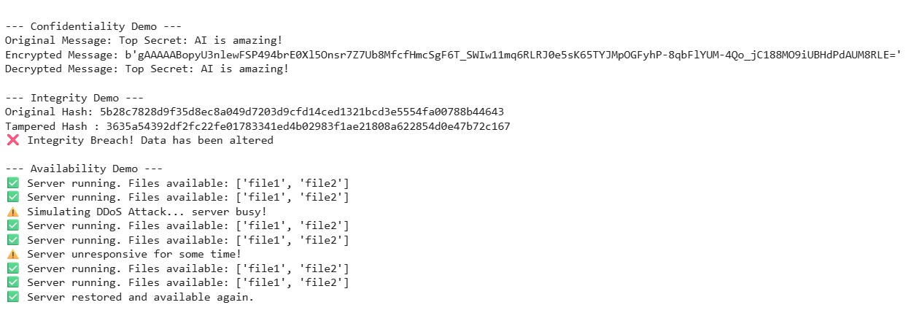
RESULT

4. Build python code for Dictionary Attack for plaintext and hash value.
- Add brute-force simulation in this GUI?
- Add password strength checker (like weak/medium/strong)?
- Export analyzed passwords by category?
- Support longer passwords (4+ characters)?
- Export analysis report as .txt or .csv?
Add real-time progress bar for brute-force

CODE IMPLEMENTATION

import hashlib
import itertools
import string
import threading
import time
import csv
import os
from tkinter import Tk, StringVar, BooleanVar, IntVar, filedialog, messagebox, END
from tkinter import ttk
from tkinter.scrolledtext import ScrolledText

# ----------------------------- Utility functions -----------------------------

def hash_text(text: str, algo: str) -> str:
t = text.encode("utf-8", errors="ignore")
algo = algo.lower()
if algo == "md5":
return hashlib.md5(t).hexdigest()
if algo == "sha1":
return hashlib.sha1(t).hexdigest()
if algo == "sha256":
return hashlib.sha256(t).hexdigest()
raise ValueError("Unsupported algorithm")

def detect_hash_algo(hexstr: str) -> str | None:
s = hexstr.strip().lower()
if all(c in string.hexdigits for c in s):
if len(s) == 32:
return "md5"
if len(s) == 40:
return "sha1"
if len(s) == 64:
return "sha256"
return None

COMMON_WEAK = {
"123456", "password", "qwerty", "111111", "letmein", "abc123", "12345678",
"iloveyou", "admin", "welcome", "monkey", "dragon", "football", "login"
}

def password_strength(pw: str, dictionary_set: set[str] | None = None) -> tuple[str, float, list[str]]:
reasons = []
length = len(pw)
variety = sum([
any(c.islower() for c in pw),
any(c.isupper() for c in pw),
any(c.isdigit() for c in pw),
any(c in string.punctuation for c in pw),
])
score = min(60, length * 4) + variety * 10
if pw.lower() in COMMON_WEAK:
score -= 30; reasons.append("in common weak list")
if pw.isdigit() and length < 8:
score -= 20; reasons.append("short digits-only")
if dictionary_set and pw.lower() in dictionary_set:
score -= 15; reasons.append("found in dictionary")
score = max(0, min(100, score))
if score < 40: cat = "Weak"
elif score < 70: cat = "Medium"
else: cat = "Strong"
if not reasons:
reasons.append({"Weak":"short or low variety","Medium":"ok but could be longer/more diverse","Strong":"good length and variety"}[cat])
return cat, float(score), reasons

# ----------------------------- Attack controller -----------------------------

class AttackController:
def __init__(self, log_callback, progress_callback, live_callback, done_callback):
self.stop_event = threading.Event()
self.log = log_callback
self.progress = progress_callback
self.live = live_callback
self.done = done_callback
self.total = 0
self.attempts = 0
self.start_time = None

def reset(self):
self.stop_event.clear()
self.total = 0
self.attempts = 0
self.start_time = time.time()

def request_stop(self):
self.stop_event.set()

def should_stop(self):
return self.stop_event.is_set()

# ----------------------------- Attack workers -----------------------------

def dict_attack(controller: AttackController, target: str, mode: str, algo: str, words: list[str]):
controller.reset()
controller.total = len(words)
found = None
for i, w in enumerate(words, 1):
if controller.should_stop():
controller.log("\n[!] Attack cancelled by user.")
controller.done(None, cancelled=True); return
w = w.strip("\r\n")
controller.attempts = i
# Live guess (throttled)
if i % 50 == 0 or i == 1:
controller.live(f"Trying: {w}")
match = (w == target) if mode == 'plaintext' else (hash_text(w, algo) == target.lower())
if i % 200 == 0 or i == controller.total:
controller.progress(controller.attempts, controller.total)
if match:
found = w
controller.log(f"[+] Found: '{w}' after {i} attempts")
break
if not found:
controller.log("[-] No match in dictionary.")
controller.done(found, cancelled=False)

def brute_force_attack(controller: AttackController, target: str, mode: str, algo: str,
charset: str, min_len: int, max_len: int):
controller.reset()
total = sum(len(charset) ** L for L in range(min_len, max_len + 1))
controller.total = total
attempts = 0
for L in range(min_len, max_len + 1):
for combo in itertools.product(charset, repeat=L):
if controller.should_stop():
controller.log("\n[!] Attack cancelled by user.")
controller.done(None, cancelled=True); return
cand = ''.join(combo)
attempts += 1
controller.attempts = attempts
# Live guess (throttled)
if attempts % 200 == 0 or attempts == 1:
controller.live(f"Trying: {cand}")
match = (cand == target) if mode == 'plaintext' else (hash_text(cand, algo) == target.lower())
if attempts % 2000 == 0 or attempts == total:
controller.progress(attempts, total)
if match:
controller.log(f"[+] Found: '{cand}' after {attempts} attempts")
controller.progress(attempts, total)
controller.done(cand, cancelled=False); return
controller.log("[-] Not found in brute-force range.")
controller.done(None, cancelled=False)

# --------------------------------- GUI ---------------------------------

class App:
def __init__(self, root: Tk):
self.root = root
root.title("Dictionary & Brute-Force Password Demo (Educational)")
root.geometry("980x740")

self.controller = AttackController(
log_callback=self.log,
progress_callback=self.update_progress,
live_callback=self.update_live_guess,
done_callback=self.on_done
)

# Vars
self.mode = StringVar(value="hash")
self.hash_algo = StringVar(value="md5")
self.target_input = StringVar()
self.auto_detect = BooleanVar(value=True)

self.charset_choice = StringVar(value="lower+digits")
self.min_len = IntVar(value=1)
self.max_len = IntVar(value=4)

self.words: list[str] = [
"password","123456","qwerty","letmein","welcome","admin","iloveyou",
"dragon","monkey","football","login","abc123"
]
self.analysis_results = {"Weak": [], "Medium": [], "Strong": []}

self._build_ui()

# ---------- UI builders ----------
def _build_ui(self):
nb = ttk.Notebook(self.root); nb.pack(fill="both", expand=True, padx=8, pady=8)
self.tab_attack = ttk.Frame(nb); self.tab_analyze = ttk.Frame(nb); self.tab_log = ttk.Frame(nb)
nb.add(self.tab_attack, text="Attack")
nb.add(self.tab_analyze, text="Analyze Passwords")
nb.add(self.tab_log, text="Log & Export")
self._build_attack_tab()
self._build_analyze_tab()
self._build_log_tab()

def _build_attack_tab(self):
frm = ttk.Frame(self.tab_attack); frm.pack(fill="x", padx=10, pady=10)

# Target
row1 = ttk.Frame(frm); row1.pack(fill="x", pady=4)
ttk.Label(row1, text="Target (password or hash):").pack(side="left")
ttk.Entry(row1, textvariable=self.target_input, width=70).pack(side="left", padx=6)
ttk.Button(row1, text="Paste", command=self._paste).pack(side="left")
ttk.Checkbutton(row1, text="Auto-detect hash algo", variable=self.auto_detect).pack(side="left", padx=6)

# Mode & algo + Strength Check
row2 = ttk.Frame(frm); row2.pack(fill="x", pady=4)
ttk.Label(row2, text="Mode:").pack(side="left")
ttk.Radiobutton(row2, text="Hash target", variable=self.mode, value="hash").pack(side="left")
ttk.Radiobutton(row2, text="Plaintext target", variable=self.mode, value="plaintext").pack(side="left")
ttk.Label(row2, text="Algorithm:").pack(side="left", padx=(20, 2))
algo_combo = ttk.Combobox(row2, textvariable=self.hash_algo, values=["md5","sha1","sha256"], width=8)
algo_combo.pack(side="left", padx=(0,10))
ttk.Button(row2, text="Check Strength", command=self.check_strength_button).pack(side="left")

# Dictionary controls
dictf = ttk.LabelFrame(self.tab_attack, text="Dictionary Attack")
dictf.pack(fill="x", padx=10, pady=6)
ttk.Label(dictf, text=f"Loaded words: (default {len(self.words)}). You can load your own wordlist file.").pack(anchor="w", padx=8, pady=2)
btns = ttk.Frame(dictf); btns.pack(fill="x", padx=6, pady=4)
ttk.Button(btns, text="Load Wordlist...", command=self.load_wordlist).pack(side="left")
ttk.Button(btns, text="Start Dictionary Attack", command=self.start_dict_attack).pack(side="left", padx=6)

# Brute-force controls
bf = ttk.LabelFrame(self.tab_attack, text="Brute-Force Attack (Simulation)")
bf.pack(fill="x", padx=10, pady=6)
ttk.Label(bf, text="Charset:").grid(row=0, column=0, sticky="w", padx=6, pady=3)
ttk.Combobox(bf, textvariable=self.charset_choice, values=[
"lower","digits","lower+digits","letters","letters+digits","letters+digits+symbols"
], width=24).grid(row=0, column=1, sticky="w", padx=4)
ttk.Label(bf, text="Min length:").grid(row=0, column=2, sticky="w", padx=6)
ttk.Spinbox(bf, from_=1, to=8, textvariable=self.min_len, width=5).grid(row=0, column=3)
ttk.Label(bf, text="Max length:").grid(row=0, column=4, sticky="w", padx=6)
ttk.Spinbox(bf, from_=1, to=8, textvariable=self.max_len, width=5).grid(row=0, column=5)
ttk.Button(bf, text="Start Brute-Force", command=self.start_brute_force).grid(row=0, column=6, padx=8)
ttk.Button(bf, text="Cancel", command=self.cancel_attack).grid(row=0, column=7, padx=4)

# Progress + live guess
progf = ttk.LabelFrame(self.tab_attack, text="Progress")
progf.pack(fill="x", padx=10, pady=8)
self.progress_var = IntVar(value=0)
self.progressbar = ttk.Progressbar(progf, orient="horizontal", length=600, mode="determinate", maximum=1000)
self.progressbar.pack(fill="x", padx=8, pady=6)
self.status_var = StringVar(value="Idle")
ttk.Label(progf, textvariable=self.status_var).pack(anchor="w", padx=8)
self.live_var = StringVar(value="") # <- NEW live guess label
ttk.Label(progf, textvariable=self.live_var, foreground="#555").pack(anchor="w", padx=8, pady=(2,6))

def _build_analyze_tab(self):
frm = ttk.Frame(self.tab_analyze); frm.pack(fill="both", expand=True, padx=10, pady=10)
ttk.Label(frm, text="Analyze passwords from a file (one per line), then export by category:").pack(anchor="w")
top = ttk.Frame(frm); top.pack(fill="x", pady=6)
ttk.Button(top, text="Load Password List...", command=self.load_password_list).pack(side="left")
ttk.Button(top, text="Export CSV", command=lambda: self.export_analysis("csv")).pack(side="left", padx=6)
ttk.Button(top, text="Export TXT", command=lambda: self.export_analysis("txt")).pack(side="left")
self.tree = ttk.Treeview(frm, columns=("password","category","score","notes"), show="headings")
for col, w in (("password",260),("category",100),("score",80),("notes",360)):
self.tree.heading(col, text=col.capitalize()); self.tree.column(col, width=w)
self.tree.pack(fill="both", expand=True, pady=6)

def _build_log_tab(self):
frm = ttk.Frame(self.tab_log); frm.pack(fill="both", expand=True, padx=10, pady=10)
self.logbox = ScrolledText(frm, height=22); self.logbox.pack(fill="both", expand=True)
btns = ttk.Frame(frm); btns.pack(fill="x", pady=6)
ttk.Button(btns, text="Save Log as TXT", command=self.save_log).pack(side="left")
ttk.Button(btns, text="Clear Log", command=lambda: self.logbox.delete('1.0', END)).pack(side="left", padx=6)

# ---------- Handlers ----------
def _paste(self):
try:
self.target_input.set(self.root.clipboard_get())
except Exception:
pass

def check_strength_button(self):
target = self.target_input.get().strip()
if not target:
messagebox.showwarning("Input", "Enter a target first."); return
if self.mode.get() == "hash":
messagebox.showinfo("Strength", "Strength applies to plaintext.\nSwitch to 'Plaintext target' to evaluate."); return
dict_set = set(w.lower() for w in self.words)
cat, score, reasons = password_strength(target, dict_set)
msg = f"Strength: {cat} (score {score:.0f})\n- " + "\n- ".join(reasons)
self.status_var.set(f"Strength: {cat} (score {score:.0f})")
self.log(msg)

def load_wordlist(self):
path = filedialog.askopenfilename(title="Choose wordlist", filetypes=[("Text","*.txt"),("All","*.*")])
if not path: return
try:
with open(path, "r", encoding="utf-8", errors="ignore") as f:
self.words = [line.strip() for line in f if line.strip()]
messagebox.showinfo("Wordlist", f"Loaded {len(self.words)} words.")
except Exception as e:
messagebox.showerror("Error", f"Failed to load wordlist: {e}")

def start_dict_attack(self):
target = self.target_input.get().strip()
if not target:
messagebox.showwarning("Input", "Enter a target (hash or plaintext)."); return
mode = self.mode.get()
algo = self.hash_algo.get()
if mode == 'hash' and self.auto_detect.get():
guess = detect_hash_algo(target)
if guess:
algo = guess; self.hash_algo.set(guess)
self.log(f"[i] Auto-detected hash algo: {guess}")
self.status_var.set("Running dictionary attack...")
self.progressbar['value'] = 0
t = threading.Thread(target=dict_attack, args=(self.controller, target, mode, algo, list(self.words)), daemon=True)
t.start()

def start_brute_force(self):
target = self.target_input.get().strip()
if not target:
messagebox.showwarning("Input", "Enter a target (hash or plaintext)."); return
mode = self.mode.get()
algo = self.hash_algo.get()
min_len = int(self.min_len.get()); max_len = int(self.max_len.get())
if min_len > max_len:
messagebox.showwarning("Lengths", "Min length cannot exceed Max length."); return
charset = self._charset_from_choice(self.charset_choice.get())
combos = sum(len(charset) ** L for L in range(min_len, max_len + 1))
if combos > 50_000_000:
if not messagebox.askyesno("Warning", f"This will try ~{combos:,} combos. Continue?"):
return
self.status_var.set("Running brute-force...")
self.progressbar['value'] = 0
self.live_var.set("")
t = threading.Thread(target=brute_force_attack, args=(self.controller, target, mode, algo, charset, min_len, max_len), daemon=True)
t.start()

def cancel_attack(self):
self.controller.request_stop()

def update_progress(self, attempts, total):
frac = attempts / total if total else 0
self.progressbar['value'] = int(frac * 1000)
elapsed = time.time() - (self.controller.start_time or time.time())
rate = attempts / elapsed if elapsed > 0 else 0
eta = (total - attempts) / rate if rate > 0 else float('inf')
eta_txt = "∞" if eta == float('inf') else f"{int(eta)}s"
self.status_var.set(f"Attempts: {attempts:,}/{total:,} | Rate: {rate:,.0f}/s | ETA: {eta_txt}")
self.root.update_idletasks()

def update_live_guess(self, text: str):
self.live_var.set(text)

def on_done(self, found, cancelled=False):
if cancelled:
self.status_var.set("Cancelled")
elif found:
self.status_var.set(f"Found: {found}")
self.live_var.set("")
else:
self.status_var.set("Finished: not found")

def log(self, text: str):
self.logbox.insert(END, text + "\n")
self.logbox.see(END)

def _charset_from_choice(self, choice: str) -> str:
return {
"lower": string.ascii_lowercase,
"digits": string.digits,
"lower+digits": string.ascii_lowercase + string.digits,
"letters": string.ascii_letters,
"letters+digits": string.ascii_letters + string.digits,
"letters+digits+symbols": string.ascii_letters + string.digits + string.punctuation
}.get(choice, string.ascii_lowercase)

# -------- Password list analysis & export (Analyze tab) --------
def load_password_list(self):
path = filedialog.askopenfilename(title="Choose password list (one per line)", filetypes=[("Text","*.txt"),("CSV","*.csv"),("All","*.*")])
if not path: return
passwords = []
try:
if path.lower().endswith('.csv'):
with open(path, newline='', encoding='utf-8', errors='ignore') as f:
reader = csv.reader(f)
for row in reader:
if row: passwords.append(str(row[0]).strip())
else:
with open(path, 'r', encoding='utf-8', errors='ignore') as f:
passwords = [line.strip() for line in f if line.strip()]
except Exception as e:
messagebox.showerror("Error", f"Failed to read file: {e}"); return
dict_set = set(w.lower() for w in self.words)
for c in self.tree.get_children(): self.tree.delete(c)
self.analysis_results = {"Weak": [], "Medium": [], "Strong": []}
for pw in passwords:
cat, score, reasons = password_strength(pw, dict_set)
notes = "; ".join(reasons)
self.tree.insert('', END, values=(pw, cat, f"{score:.0f}", notes))
self.analysis_results[cat].append({"password": pw, "score": score, "notes": notes})
messagebox.showinfo("Analyze", f"Analyzed {len(passwords)} passwords.")

def export_analysis(self, kind: str = "csv"):
if kind not in {"csv","txt"}: return
default_name = f"password_analysis.{kind}"
path = filedialog.asksaveasfilename(defaultextension=f".{kind}", initialfile=default_name,
filetypes=[("CSV","*.csv"),("Text","*.txt")])
if not path: return
try:
if kind == "csv":
with open(path, 'w', newline='', encoding='utf-8') as f:
writer = csv.writer(f)
writer.writerow(["Category","Password","Score","Notes"])
for cat in ("Weak","Medium","Strong"):
for item in self.analysis_results[cat]:
writer.writerow([cat, item["password"], f"{item['score']:.0f}", item["notes"]])
else:
with open(path, 'w', encoding='utf-8') as f:
for cat in ("Weak","Medium","Strong"):
f.write(f"[{cat}]\n")
for item in self.analysis_results[cat]:
f.write(f"- {item['password']} (score {item['score']:.0f}) {item['notes']}\n")
f.write("\n")
messagebox.showinfo("Export", f"Saved: {os.path.basename(path)}")
except Exception as e:
messagebox.showerror("Error", f"Failed to save: {e}")

# ---------------- Log export ----------------
def save_log(self):
path = filedialog.asksaveasfilename(defaultextension=".txt", initialfile="attack_log.txt", filetypes=[("Text","*.txt")])
if not path: return
try:
with open(path, 'w', encoding='utf-8') as f:
f.write(self.logbox.get('1.0', END))
messagebox.showinfo("Saved", f"Saved log to {os.path.basename(path)}")
except Exception as e:
messagebox.showerror("Error", f"Failed to save: {e}")

# ------------------------------ Main ------------------------------

if __name__ == "__main__":
root = Tk()
try:
root.call("tk", "scaling", 1.2)
style = ttk.Style()
if "vista" in style.theme_names(): style.theme_use("vista")
elif "clam" in style.theme_names(): style.theme_use("clam")
except Exception:
pass
App(root)
root.mainloop()

SMALL VERSION

import tkinter as tk
from tkinter import filedialog, ttk, messagebox
import hashlib
import itertools
import string
import csv
import os

# ---------------- Password Strength Checker ---------------- #
def check_strength(password):
strength = 0
remarks = ""

if len(password) >= 8:
strength += 1
if any(char.isdigit() for char in password):
strength += 1
if any(char.isupper() for char in password):
strength += 1
if any(char.islower() for char in password):
strength += 1
if any(char in string.punctuation for char in password):
strength += 1

if strength <= 2:
remarks = "Weak"
elif strength == 3 or strength == 4:
remarks = "Medium"
else:
remarks = "Strong"

return remarks

# ---------------- Hashing Function ---------------- #
def sha256_hash(text):
return hashlib.sha256(text.encode()).hexdigest()

# ---------------- Dictionary Attack ---------------- #
def load_dictionary():
global dictionary_words
file_path = filedialog.askopenfilename(title="Select Dictionary File", filetypes=[("Text Files", "*.txt")])
if file_path:
with open(file_path, "r", encoding="utf-8", errors="ignore") as file:
dictionary_words = file.read().splitlines()
status_var.set(f"Dictionary Loaded: {len(dictionary_words)} words")

def run_dictionary_attack():
global dictionary_words, target_hash, found_password
if not dictionary_words:
status_var.set("No dictionary loaded!")
return

target_hash = entry_hash.get().strip()
if not target_hash:
status_var.set("Enter a hash value!")
return

status_var.set("Running Dictionary Attack...")
root.update()

for word in dictionary_words:
if sha256_hash(word) == target_hash:
status_var.set(f"Password Found: {word}")
found_password = word
return

status_var.set("Dictionary Attack Failed: No match found.")

# ---------------- Brute-force Attack ---------------- #
def run_bruteforce_attack():
global found_password
target_hash = entry_hash.get().strip()
if not target_hash:
status_var.set("Enter a hash value!")
return

max_length = int(combo_length.get())
charset = string.ascii_letters + string.digits + string.punctuation

progress_bar["value"] = 0
total_guesses = sum(len(charset) ** i for i in range(1, max_length + 1))
guess_counter = 0

status_var.set("Running Brute-force Attack...")
root.update()

for length in range(1, max_length + 1):
for guess in itertools.product(charset, repeat=length):
guess_word = ''.join(guess)
guess_counter += 1

# Update progress bar and live guess
progress_bar["value"] = (guess_counter / total_guesses) * 100
live_guess_var.set(f"Trying: {guess_word}")
root.update_idletasks()

if sha256_hash(guess_word) == target_hash:
status_var.set(f"Password Found: {guess_word}")
found_password = guess_word
return

status_var.set("Brute-force Attack Failed.")

# ---------------- Analyze Passwords ---------------- #
def analyze_passwords():
global dictionary_words
if not dictionary_words:
status_var.set("Load dictionary first for analysis!")
return

categories = {"Weak": [], "Medium": [], "Strong": []}
for word in dictionary_words:
strength = check_strength(word)
categories[strength].append(word)

analysis_results.set(f"Weak: {len(categories['Weak'])}, Medium: {len(categories['Medium'])}, Strong: {len(categories['Strong'])}")
return categories

# ---------------- Export Results ---------------- #
def export_results():
categories = analyze_passwords()
if not categories:
return

file_path = filedialog.asksaveasfilename(defaultextension=".csv",
filetypes=[("CSV Files", ".csv"), ("Text Files", ".txt")])
if not file_path:
return

ext = os.path.splitext(file_path)[1]
if ext == ".csv":
with open(file_path, "w", newline="", encoding="utf-8") as f:
writer = csv.writer(f)
writer.writerow(["Category", "Passwords"])
for cat, words in categories.items():
writer.writerow([cat, ", ".join(words)])
else:
with open(file_path, "w", encoding="utf-8") as f:
for cat, words in categories.items():
f.write(f"{cat}:\n")
f.write(", ".join(words) + "\n\n")

status_var.set(f"Results exported to {file_path}")

# ---------------- GUI ---------------- #
root = tk.Tk()
root.title("Password Cracker (Dictionary + Brute-force)")
root.geometry("600x450")

dictionary_words = []
found_password = None

# Input field
tk.Label(root, text="Enter Password / Hash (SHA-256):").pack(pady=5)
entry_hash = tk.Entry(root, width=60)
entry_hash.pack()

# Strength checker
tk.Button(root, text="Check Strength", command=lambda: status_var.set(f"Strength: {check_strength(entry_hash.get())}")).pack(pady=5)

# Dictionary Attack
tk.Button(root, text="Load Dictionary", command=load_dictionary).pack(pady=5)
tk.Button(root, text="Run Dictionary Attack", command=run_dictionary_attack).pack(pady=5)

# Brute-force Attack
tk.Label(root, text="Max Brute-force Password Length:").pack(pady=5)
combo_length = ttk.Combobox(root, values=[4,5,6], width=5)
combo_length.set(4)
combo_length.pack()

tk.Button(root, text="Run Brute-force Attack", command=run_bruteforce_attack).pack(pady=5)

progress_bar = ttk.Progressbar(root, orient="horizontal", length=400, mode="determinate")
progress_bar.pack(pady=5)

live_guess_var = tk.StringVar()
tk.Label(root, textvariable=live_guess_var).pack()

# Analysis + Export
tk.Button(root, text="Analyze Passwords", command=analyze_passwords).pack(pady=5)
tk.Button(root, text="Export Results", command=export_results).pack(pady=5)

# Status
status_var = tk.StringVar(value="Status: Waiting...")
tk.Label(root, textvariable=status_var, fg="blue").pack(pady=10)

analysis_results = tk.StringVar()
tk.Label(root, textvariable=analysis_results, fg="green").pack()

root.mainloop()

RESULTS

- Password check
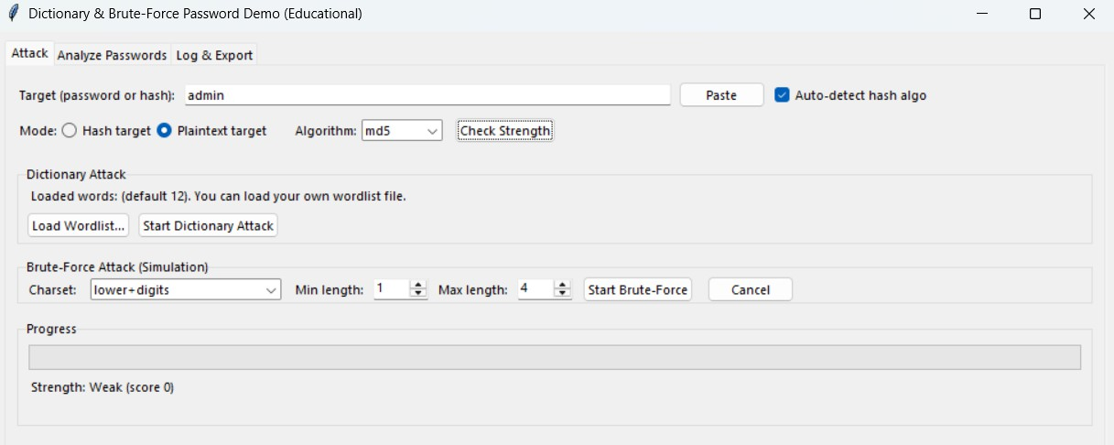

- Dictionary Attack
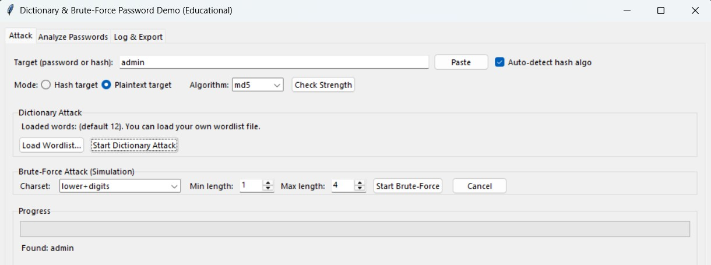

- Brute force attack
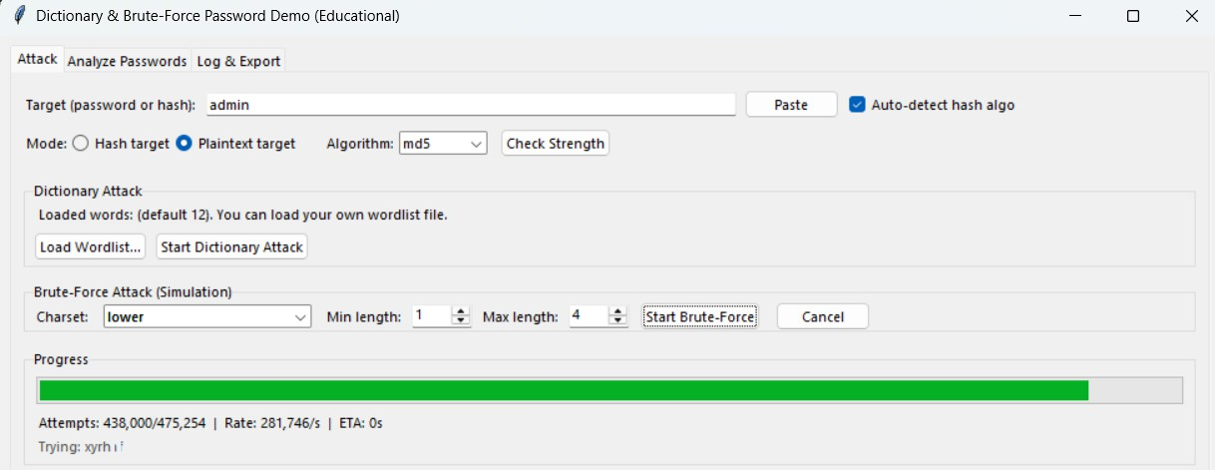

- Password analyzed by category
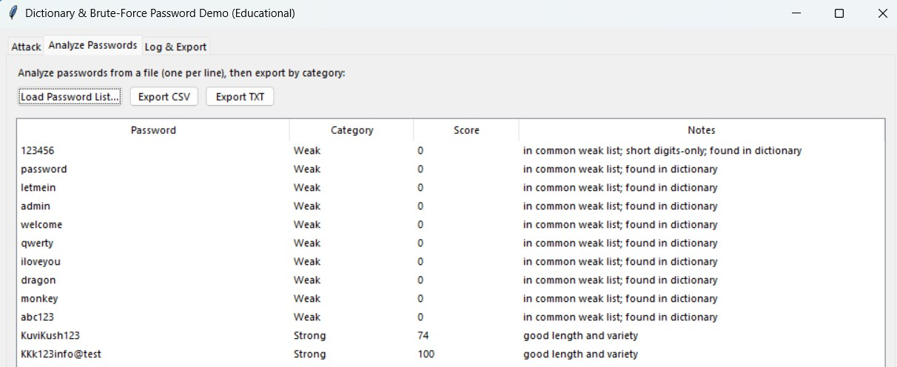
- Log of Attacks
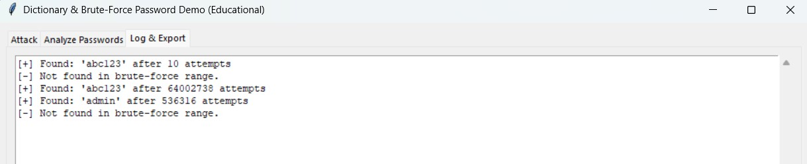

- Support for Longer Passwords
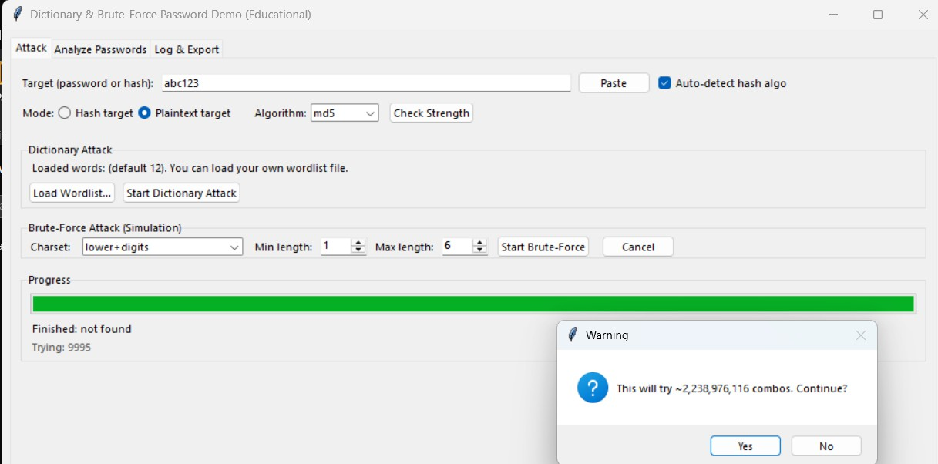

5. Build a virus simulation tool — safe, educational, and non-malicious — to help you understand how malware might behave in a system, and how defenders can detect or prevent it.

CODE IMPLEMENTATION
import random
import tkinter as tk
from tkinter import messagebox, scrolledtext

# -------------------------
# File Object
class File:
def __init__(self, name):
self.name = name
self.infected = False
self.quarantined = False
self.quarantine_timer = 0

# -------------------------
# Computer Object
class Computer:
def __init__(self, name, file_count=6):
self.name = name
self.files = [File(f"{name}_file_{i}.txt") for i in range(file_count)]
self.infected = False

def infect_file(self, chance=0.3):
target = random.choice(self.files)
if not target.infected and not target.quarantined and random.random() < chance:
target.infected = True
self.infected = True
return target.name
return None

def spread_within(self, chance=0.2):
events = []
for file in self.files:
if file.infected and not file.quarantined:
target = random.choice(self.files)
if not target.infected and random.random() < chance:
target.infected = True
self.infected = True
events.append(f"{target.name} infected internally")
return events

def scan_and_quarantine(self, chance=0.3):
events = []
for file in self.files:
if file.infected and not file.quarantined and random.random() < chance:
file.quarantined = True
file.quarantine_timer = 2
events.append(f"{file.name} quarantined")
return events

def recover_files(self):
events = []
for file in self.files:
if file.quarantined:
file.quarantine_timer -= 1
if file.quarantine_timer <= 0:
file.infected = False
file.quarantined = False
events.append(f"{file.name} recovered")
self.infected = any(f.infected for f in self.files)
return events

# -------------------------
# Virus Simulation (grid-based only)
class VirusSimulation:
def __init__(self, gui, computers=6, files=6, infection_chance=0.4, detection_chance=0.3):
self.gui = gui
self.computers = [Computer(f"PC_{i}", files) for i in range(computers)]
self.infection_chance = infection_chance
self.detection_chance = detection_chance

def infect_random_computer(self, initial_infections=1):
events = []
for _ in range(initial_infections):
comp_idx = random.randrange(len(self.computers))
name = self.computers[comp_idx].infect_file(chance=1.0)
events.append(f"{self.computers[comp_idx].name} initial infection -> {name}")
return events

def step_cycle(self):
events = []
for comp in self.computers:
events += comp.spread_within()
for i, comp in enumerate(self.computers):
if comp.infected:
target = random.choice([c for c in self.computers if c != comp])
fname = target.infect_file(self.infection_chance)
if fname:
events.append(f"{target.name}: {fname} infected from {comp.name}")
for comp in self.computers:
events += comp.scan_and_quarantine(self.detection_chance)
for comp in self.computers:
events += comp.recover_files()
return events

def get_totals(self):
total_files = sum(len(c.files) for c in self.computers)
infected = sum(f.infected for c in self.computers for f in c.files)
quarantined = sum(f.quarantined for c in self.computers for f in c.files)
return total_files, infected, quarantined

# -------------------------
# GUI Class (grid only)
class VirusSimulationGUI:

def __init__(self, root):
self.root = root
self.root.title("💻 Virus Simulation Tool — Grid View")
self.root.geometry("1200x700")
self.root.configure(bg="#0f1724")
self.cycle_stats = [] # track per-cycle stats

# Controls
control_frame = tk.Frame(root, bg="#091025", padx=12, pady=12)
control_frame.pack(side='left', fill='y')

tk.Label(control_frame, text="Controls", bg="#091025", fg="#ffffff", font=("Segoe UI", 12, "bold")).pack(pady=6)

self.entry_computers = self._add_input(control_frame, "Computers", "6")
self.entry_files = self._add_input(control_frame, "Files/Computer", "6")
self.entry_infect = self._add_input(control_frame, "Infection Chance (0-1)", "0.4")
self.entry_detect = self._add_input(control_frame, "Detection Chance (0-1)", "0.3")
self.entry_cycles = self._add_input(control_frame, "Cycles", "12")
self.entry_delay = self._add_input(control_frame, "Delay (ms)", "800")

btn_frame = tk.Frame(control_frame, bg="#091025")
btn_frame.pack(pady=10)
self.btn_start = tk.Button(btn_frame, text="Start", command=self.start_simulation, bg="#10b981", fg="#021018",
width=10, font=("Segoe UI", 12, "bold"))
self.btn_start.grid(row=0, column=0, padx=6)
self.btn_stop = tk.Button(btn_frame, text="Stop", command=self.stop_simulation, bg="#ef4444", fg="#fff",
width=10, font=("Segoe UI", 12, "bold"), state='disabled')
self.btn_stop.grid(row=0, column=1, padx=6)

reset_btn = tk.Button(control_frame, text="Reset Log", command=self.reset_log, bg="#374151", fg="#fff", font=("Segoe UI", 11))
reset_btn.pack(pady=6)

# Main display
self.grid_frame = tk.Frame(root, bg="#071020")
self.grid_frame.pack(side='left', fill='both', expand=True, padx=8, pady=8)

bottom = tk.Frame(root, bg="#06101a", height=180)
bottom.pack(fill='x')
stats_l = tk.Frame(bottom, bg="#06101a")
stats_l.pack(side='left', fill='y', padx=8, pady=8)
tk.Label(stats_l, text="Stats", bg="#06101a", fg="#bfe9ff", font=("Segoe UI", 11, "bold")).pack(anchor='nw')
self.stats_text = tk.Label(stats_l, text="Ready", bg="#06101a", fg="#e6f7ff", justify='left')
self.stats_text.pack(anchor='nw')

log_frame = tk.Frame(bottom, bg="#000")
log_frame.pack(side='right', fill='both', expand=True, padx=8, pady=8)
tk.Label(log_frame, text="Event Log", bg="#000", fg="#8cffc9", font=("Consolas", 10, "bold")).pack(anchor='nw')
self.log_box = scrolledtext.ScrolledText(
log_frame,
height=20, # more lines visible
width=80, # wider display
bg="#020202",
fg="#b7f5d6",
font=("Consolas", 10),
wrap=tk.WORD # wraps long lines instead of horizontal scroll
)
self.log_box.pack(fill='both', expand=True)

# Internal simulation state
self.simulation = None
self.current_cycle = 0
self.total_cycles = 0
self.running = False
self.delay_ms = 800

def _add_input(self, frame, label, default):
tk.Label(frame, text=label, bg="#091025", fg="#cfe7ff").pack(pady=2, anchor='w')
entry = tk.Entry(frame, width=12)
entry.insert(0, default)
entry.pack(pady=2)
return entry

def reset_log(self):
self.log_box.delete('1.0', tk.END)

def start_simulation(self):
try:
computers = int(self.entry_computers.get())
files = int(self.entry_files.get())
infect = float(self.entry_infect.get())
detect = float(self.entry_detect.get())
cycles = int(self.entry_cycles.get())
delay = int(self.entry_delay.get())
except ValueError:
messagebox.showerror("Input error", "Please enter valid numeric values")
return

self.simulation = VirusSimulation(self, computers, files, infect, detect)
inits = self.simulation.infect_random_computer(initial_infections=max(1, computers//4))
for e in inits:
self.log(e)

self.current_cycle = 0
self.total_cycles = cycles
self.delay_ms = delay
self.running = True
self.btn_start.config(state='disabled')
self.btn_stop.config(state='normal')
self.cycle_stats = [] # reset stats for new simulation

self.update_grid()
self.root.after(400, self.run_cycle)

def stop_simulation(self):
self.running = False
self.btn_start.config(state='normal')
self.btn_stop.config(state='disabled')
self.log('[STOP] Simulation halted')

def run_cycle(self):
if not self.running:
return

if self.current_cycle >= self.total_cycles:
self.running = False
self.btn_start.config(state='normal')
self.btn_stop.config(state='disabled')
self.log(f'[END] Completed {self.total_cycles} cycles')

# --- Final cumulative summary ---
self.log("\n=== FINAL CUMULATIVE SUMMARY ===")
for i, (inf, quar) in enumerate(self.cycle_stats, start=1):
self.log(f"Cycle {i}: Infected = {inf}, Quarantined = {quar}")
return

self.current_cycle += 1
events = self.simulation.step_cycle()
self.update_grid()

# Track per-cycle stats
total_files, infected, quarantined = self.simulation.get_totals()
self.cycle_stats.append((infected, quarantined))

self.log(f'[CYCLE {self.current_cycle}] {len(events)} events')
for ev in events:
self.log(f' - {ev}')
self.root.after(self.delay_ms, self.run_cycle)

def update_grid(self):
# Update stats
total_files, infected, quarantined = self.simulation.get_totals()
self.stats_text.config(text=f"Cycles: {self.current_cycle}/{self.total_cycles}\n"
f"Files: {total_files}\n"
f"Infected: {infected}\n"
f"Quarantined: {quarantined}")

# Clear grid
for widget in self.grid_frame.winfo_children():
widget.destroy()

# Draw grid
cols = 4
for idx, comp in enumerate(self.simulation.computers):
cf = tk.LabelFrame(self.grid_frame, text=comp.name, bg='#0b1220', fg='#cfe7ff', font=("Segoe UI", 10, "bold"))
cf.grid(row=idx//cols, column=idx%cols, padx=8, pady=8)
for f in comp.files:
color = '#32CD32' if not f.infected and not f.quarantined else ('#FFD700' if f.quarantined else '#FF6347')
tk.Label(cf, text=f.name, bg=color, width=20, anchor='w', font=("Segoe UI", 9)).pack(anchor='w', pady=1)

def log(self, msg):
self.log_box.insert(tk.END, msg + "\n")
self.log_box.see(tk.END)

# -------------------------
if __name__ == '__main__':
root = tk.Tk()
app = VirusSimulationGUI(root)
root.mainloop()

RESULT

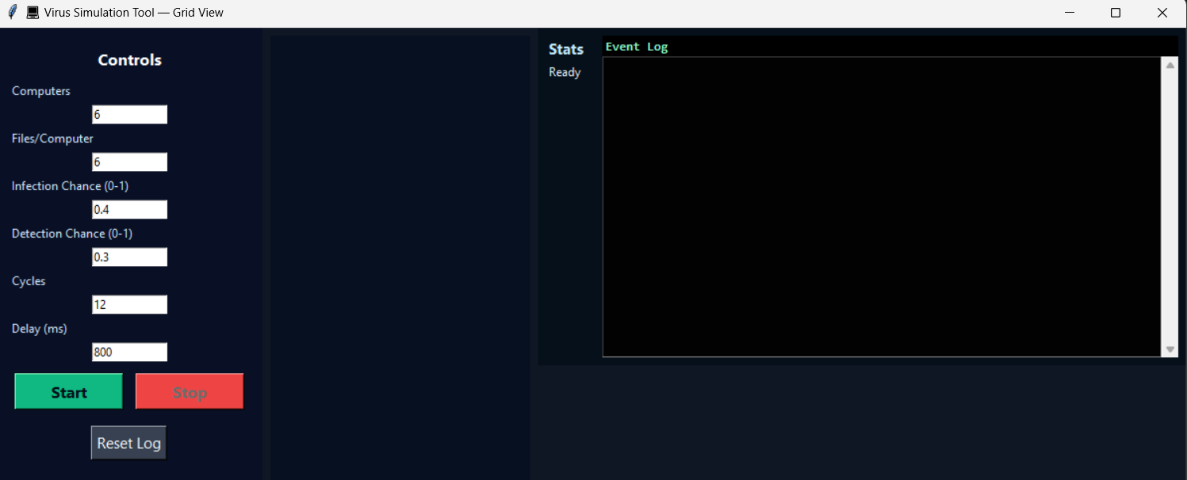

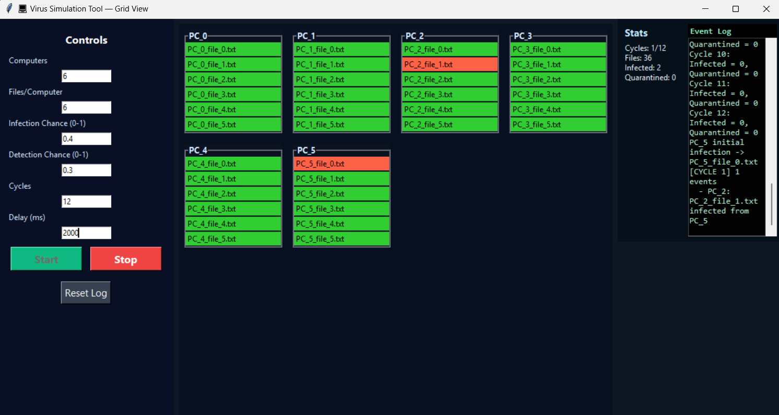

6. Build a Vulnerability Analyser Tool in Python that can scan source code files (any programming language) for common security vulnerabilities or bad coding patterns.

CODE IMPLEMENTATION
import tkinter as tk
from tkinter import filedialog, messagebox, scrolledtext
import os
import re

# -------------------------
# Define patterns with severity
vuln_patterns = {
"Use of eval()": {"pattern": r"\beval\(", "severity": "Critical", "suggestion": "Use ast.literal_eval() instead"},
"Use of exec()": {"pattern": r"\bexec\(", "severity": "Critical", "suggestion": "Avoid using exec()"},
"Hardcoded password": {"pattern": r"(password|passwd|secret|apikey)\s*=\s*['\"].+['\"]",
"severity": "High", "suggestion": "Use environment variables or config files"},
"SQL Injection Risk": {"pattern": r"(SELECT|INSERT|UPDATE|DELETE).*\+.*['\"]",
"severity": "Medium", "suggestion": "Use parameterized queries"},
"Use of os.system": {"pattern": r"os\.system\(", "severity": "High", "suggestion": "Use subprocess with sanitization"},
"Use of subprocess without sanitization": {"pattern": r"subprocess\.(call|Popen|run)\(", "severity": "High",
"suggestion": "Ensure proper sanitization"},
}

supported_extensions = ['.py', '.js', '.php', '.java', '.c', '.cpp', '.rb']

# -------------------------
def scan_code(file_path):
vulnerabilities_found = []
try:
with open(file_path, "r", encoding="utf-8", errors="ignore") as f:
lines = f.readlines()
except Exception as e:
return []

for i, line in enumerate(lines, start=1):
for vuln, info in vuln_patterns.items():
if re.search(info["pattern"], line, re.IGNORECASE):
# Get context lines (2 before, 2 after)
start = max(0, i-3)
end = min(len(lines), i+2)
context = "".join(lines[start:end]).strip()
vulnerabilities_found.append({
"file": file_path,
"line": i,
"type": vuln,
"severity": info["severity"],
"code": line.strip(),
"context": context,
"suggestion": info["suggestion"]
})
return vulnerabilities_found

def scan_directory(directory):
all_vulnerabilities = []
for root, _, files in os.walk(directory):
for file in files:
if any(file.endswith(ext) for ext in supported_extensions):
file_path = os.path.join(root, file)
vulns = scan_code(file_path)
all_vulnerabilities.extend(vulns)
return all_vulnerabilities

# -------------------------
# GUI
class VulnerabilityScannerGUI:
def __init__(self, root):
self.root = root
self.root.title("🛡 Vulnerability Analyzer Tool")
self.root.geometry("1000x700")
self.root.configure(bg="#0f1724")

# Top controls
control_frame = tk.Frame(root, bg="#091025", pady=10)
control_frame.pack(fill='x')

tk.Label(control_frame, text="Vulnerability Analyzer", bg="#091025", fg="#9ecbff",
font=("Segoe UI", 16, "bold")).pack(side='left', padx=10)

tk.Button(control_frame, text="Scan File", command=self.select_file,
bg="#10b981", fg="#fff", font=("Segoe UI", 11, "bold")).pack(side='left', padx=10)
tk.Button(control_frame, text="Scan Directory", command=self.select_directory,
bg="#3b82f6", fg="#fff", font=("Segoe UI", 11, "bold")).pack(side='left', padx=10)
tk.Button(control_frame, text="Clear Results", command=self.clear_results,
bg="#ef4444", fg="#fff", font=("Segoe UI", 11, "bold")).pack(side='left', padx=10)

# Scrollable frame for results
self.canvas = tk.Canvas(root, bg="#071020")
self.scroll_frame = tk.Frame(self.canvas, bg="#071020")
self.scrollbar = tk.Scrollbar(root, orient="vertical", command=self.canvas.yview)
self.canvas.configure(yscrollcommand=self.scrollbar.set)

self.scrollbar.pack(side='right', fill='y')
self.canvas.pack(side='left', fill='both', expand=True)
self.canvas.create_window((0, 0), window=self.scroll_frame, anchor='nw')
self.scroll_frame.bind("<Configure>", lambda e: self.canvas.configure(scrollregion=self.canvas.bbox("all")))

def clear_results(self):
for widget in self.scroll_frame.winfo_children():
widget.destroy()

def display_vulnerability(self, vuln):
# Each vulnerability in its own frame
frame = tk.LabelFrame(self.scroll_frame, text=f"{vuln['severity']} - {vuln['type']}",
bg="#0b1220", fg="#f0f0f0", font=("Segoe UI", 10, "bold"), padx=8, pady=8)
frame.pack(fill='x', padx=10, pady=6)

tk.Label(frame, text=f"File: {vuln['file']}", bg="#0b1220", fg="#a5f3fc", anchor='w', font=("Segoe UI", 10, "bold")).pack(fill='x')
tk.Label(frame, text=f"Line: {vuln['line']}", bg="#0b1220", fg="#a5f3fc").pack(anchor='w')
tk.Label(frame, text=f"Code: {vuln['code']}", bg="#0b1220", fg="#ffedd5").pack(anchor='w')
tk.Label(frame, text="Context:", bg="#0b1220", fg="#c7d2fe", font=("Segoe UI", 9, "italic")).pack(anchor='w', pady=(4,0))
ctx_box = scrolledtext.ScrolledText(frame, height=5, bg="#020202", fg="#f9f5ff", font=("Consolas", 10))
ctx_box.insert(tk.END, vuln['context'])
ctx_box.configure(state='disabled')
ctx_box.pack(fill='x', pady=2)
tk.Label(frame, text=f"Suggestion: {vuln['suggestion']}", bg="#0b1220", fg="#6ee7b7", font=("Segoe UI", 9, "italic")).pack(anchor='w', pady=(2,0))

def scan_and_display(self, path):
self.clear_results()
if os.path.isfile(path):
results = scan_code(path)
else:
results = scan_directory(path)

if results:
for vuln in results:
self.display_vulnerability(vuln)
else:
messagebox.showinfo("Scan Complete", "No vulnerabilities found!")

def select_file(self):
path = filedialog.askopenfilename(title="Select a file")
if path:
self.scan_and_display(path)

def select_directory(self):
path = filedialog.askdirectory(title="Select a directory")
if path:
self.scan_and_display(path)

# -------------------------
if __name__ == "__main__":
root = tk.Tk()
app = VulnerabilityScannerGUI(root)
root.mainloop()

RESULTS

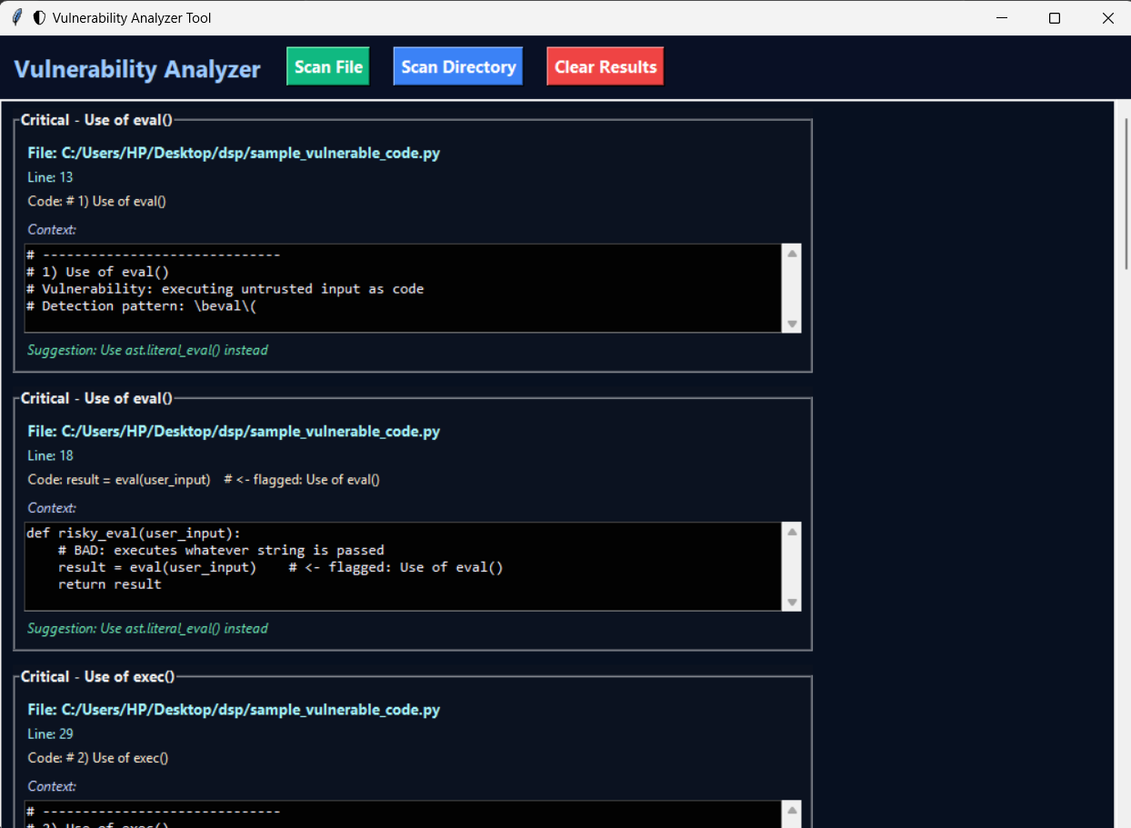

7. Phishing Website Detection using Python: Use a dataset of phishing and legitimate websites. Train a simple ML model using scikit-learn to classify URLs based on features like length, presence of @, https, etc.

CODE IMPLEMENTATION

import tkinter as tk
from tkinter import messagebox
import pandas as pd
from sklearn.ensemble import RandomForestClassifier
from sklearn.metrics import accuracy_score
from sklearn.model_selection import train_test_split

# --------------------------
# Load dataset
dataset_file = "C:/Users/HP/Desktop/dsp/URL_dataset[1].csv"

df = pd.read_csv(dataset_file, encoding='ISO-8859-1', on_bad_lines='skip')

# Map labels: legitimate -> 0, phishing -> 1
df['Label'] = df['type'].map({'legitimate': 0, 'phishing': 1})

# --------------------------
# Feature extraction function
def extract_features(url):
features = []
features.append(len(url)) # URL length
features.append(1 if '@' in url else 0) # '@' symbol
features.append(1 if url.startswith('https') else 0) # 'https'
features.append(url.count('-')) # number of '-'
features.append(url.count('.')) # number of '.'
suspicious_words = ['login', 'verify', 'secure', 'update', 'account']
features.append(1 if any(word in url.lower() for word in suspicious_words) else 0) # suspicious words
return features

# Apply feature extraction
X = df['url'].astype(str).apply(lambda x: extract_features(x)).tolist()
y = df['Label']

# --------------------------
# Train/Test Split
X_train, X_test, y_train, y_test = train_test_split(
X, y, test_size=0.2, random_state=42, stratify=y
)

# Train model
model = RandomForestClassifier(n_estimators=100, random_state=42)
model.fit(X_train, y_train)

# Evaluate model
y_pred = model.predict(X_test)
print("Model Accuracy (on test set):", accuracy_score(y_test, y_pred))

# --------------------------
# GUI Application
class PhishingDetectorApp:
def __init__(self, root):
self.root = root
self.root.title("Phishing Website Detector")
self.root.geometry("450x250")

tk.Label(root, text="Enter URL to Check:", font=("Arial", 14)).pack(pady=10)
self.url_entry = tk.Entry(root, width=50)
self.url_entry.pack(pady=5)

tk.Button(root, text="Check URL", font=("Arial", 12), command=self.check_url).pack(pady=15)

self.result_label = tk.Label(root, text="", font=("Arial", 12))
self.result_label.pack(pady=10)

def check_url(self):
url = self.url_entry.get().strip()
if not url:
messagebox.showwarning("Input Error", "Please enter a URL.")
return

features = extract_features(url)
prediction = model.predict([features])[0]

if prediction == 1:
self.result_label.config(text="⚠️ Warning: Phishing Website Detected!", fg="red")
else:
self.result_label.config(text="✅ Safe: Legitimate Website", fg="green")

# --------------------------
if __name__ == "__main__":
root = tk.Tk()
app = PhishingDetectorApp(root)
root.mainloop()

RESULTS

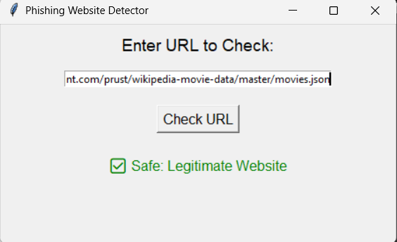

8.Develop a real-time messaging application where two devices can communicate securely. The application must use Transport Layer Security (TLS) for securing the client-server communication and End-to-End Encryption (E2EE) to ensure that only the sender and recipient can access the message content. The server should act solely as a message relay and have no access to plaintext messages.

import socket, ssl, threading, time, base64, hashlib
from cryptography.fernet import Fernet
import tkinter as tk
from tkinter import scrolledtext

HOST = "127.0.0.1"
PORT = 12345

# --- derive Fernet key from passphrase ---
def derive_key(passphrase):
return base64.urlsafe_b64encode(hashlib.sha256(passphrase.encode()).digest())

class ChatClientPanel:
def __init__(self, parent, name, passphrase, side, color):
self.name = name
self.color = color
self.cipher = Fernet(derive_key(passphrase))

# Frame for this client
frame = tk.Frame(parent, bd=3, relief="ridge")
frame.pack(side=side, fill="both", expand=True, padx=5, pady=5)

# Title
tk.Label(frame, text=f"Client: {name}", font=("Arial", 12, "bold")).pack(pady=5)

# Chat box
self.chat_area = scrolledtext.ScrolledText(
frame, wrap=tk.WORD, state="disabled", width=50, height=20, bg="#1e1e1e", fg="white"
)
self.chat_area.pack(padx=5, pady=5)

# Add tags for colored messages
self.chat_area.tag_config("Alice", foreground="lime")
self.chat_area.tag_config("Bob", foreground="cyan")
self.chat_area.tag_config("system", foreground="white")

# Typing status
self.typing_label = tk.Label(frame, text="", fg="orange")
self.typing_label.pack()

# Entry + Send
entry_frame = tk.Frame(frame)
entry_frame.pack(pady=5)

self.entry = tk.Entry(entry_frame, width=40)
self.entry.pack(side=tk.LEFT, padx=5)
self.entry.bind("<KeyRelease>", self.send_typing_status)

send_btn = tk.Button(entry_frame, text="Send", command=self.send_message)
send_btn.pack(side=tk.LEFT)

# Setup TLS socket
context = ssl.create_default_context(ssl.Purpose.SERVER_AUTH)
context.check_hostname = False
context.verify_mode = ssl.CERT_NONE
sock = socket.create_connection((HOST, PORT))
self.ssock = context.wrap_socket(sock, server_hostname=HOST)

self.add_message("[🔒] Connected via TLS. E2EE enabled.", "system")

# Start receiver thread
threading.Thread(target=self.receive_messages, daemon=True).start()

def add_message(self, msg, sender="system", self_sent=False):
self.chat_area.config(state="normal")
if self_sent:
# Sender sees only their own text (no name prefix)
self.chat_area.insert(tk.END, msg + "\n", self.name)
else:
# Show with name if coming from the other person
if sender in ["Alice", "Bob"]:
self.chat_area.insert(tk.END, msg + "\n", sender)
else:
self.chat_area.insert(tk.END, msg + "\n", "system")
self.chat_area.yview(tk.END)
self.chat_area.config(state="disabled")

def receive_messages(self):
while True:
try:
data = self.ssock.recv(4096)
if not data:
break
msg = self.cipher.decrypt(data).decode()
if msg.startswith("[") and msg.endswith("is typing...]"):
self.typing_label.config(text=msg)
self.chat_area.after(2000, lambda: self.typing_label.config(text=""))
else:
# Example msg: "[12:00:00] Alice: Hi"
if "Alice:" in msg:
self.add_message(msg, "Alice")
elif "Bob:" in msg:
self.add_message(msg, "Bob")
else:
self.add_message(msg, "system")
except:
break

def send_typing_status(self, event=None):
status_msg = f"[{self.name} is typing...]"
encrypted = self.cipher.encrypt(status_msg.encode())
self.ssock.sendall(encrypted)

def send_message(self):
msg = self.entry.get().strip()
if msg:
timestamp = time.strftime("%H:%M:%S")
full_msg = f"[{timestamp}] {self.name}: {msg}"

# Show only msg locally (no prefix)
self.add_message(msg, self.name, self_sent=True)

# Send encrypted full msg (with name so others know sender)
encrypted = self.cipher.encrypt(full_msg.encode())
self.ssock.sendall(encrypted)

self.entry.delete(0, tk.END)

# --- Main app ---
if __name__ == "__main__":
root = tk.Tk()
root.title("Secure Chat Demo (TLS + E2EE)")

passphrase = "secretpass"

# Two clients side by side
ChatClientPanel(root, "Alice", passphrase, tk.LEFT, "lime")
ChatClientPanel(root, "Bob", passphrase, tk.RIGHT, "cyan")

root.mainloop()

SERVER.PY
import socket, ssl, threading

HOST = "127.0.0.1"
PORT = 12345

clients = [] # keep track of connected clients

def handle_client(conn, addr):
print(f"[+] {addr} connected.")
while True:
try:
data = conn.recv(4096)
if not data:
break
# broadcast encrypted message to all other clients
for client in clients:
if client != conn:
client.sendall(data)
except:
break
conn.close()
clients.remove(conn)
print(f"[-] {addr} disconnected.")

def main():
context = ssl.SSLContext(ssl.PROTOCOL_TLS_SERVER)
context.load_cert_chain(certfile="cert.pem", keyfile="key.pem")

with socket.socket(socket.AF_INET, socket.SOCK_STREAM, 0) as sock:
sock.bind((HOST, PORT))
sock.listen(5)
print(f"[*] Server listening on {HOST}:{PORT} with TLS...")

with context.wrap_socket(sock, server_side=True) as ssock:
while True:
conn, addr = ssock.accept()
clients.append(conn)
threading.Thread(target=handle_client, args=(conn, addr), daemon=True).start()

if __name__ == "__main__":
main()

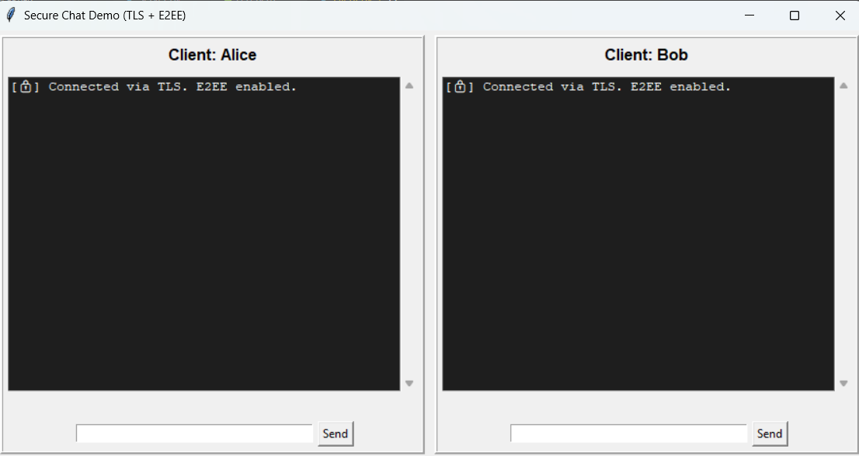
RESULTS

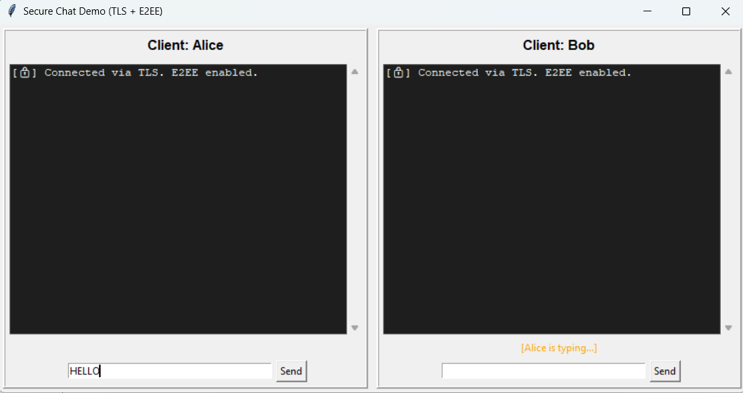

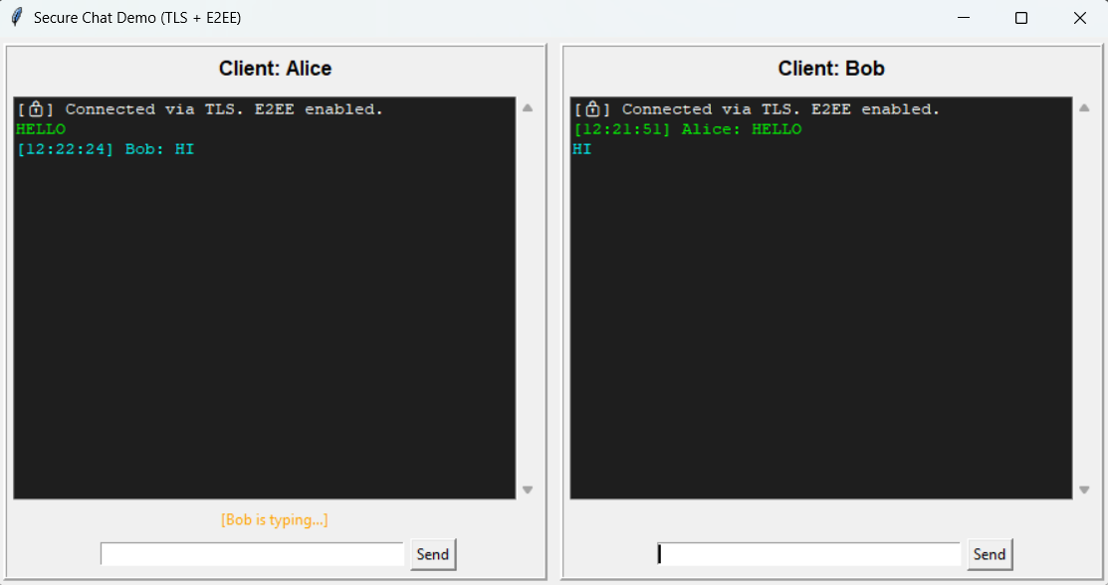
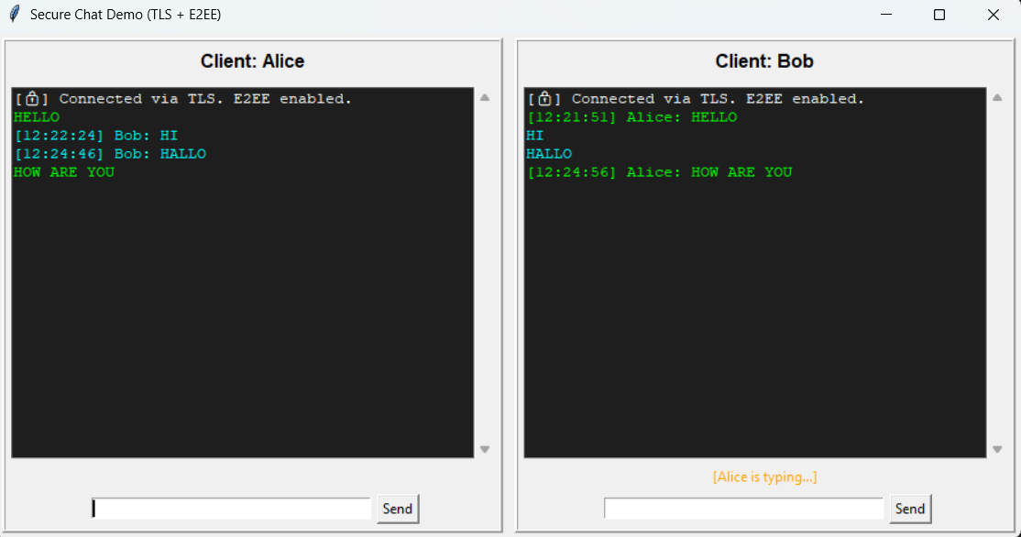

9 a. Implement common hash functions (e.g., SHA-256, MD5) using Python's hashlib. Input: A string or file. Output: Its hash value.

CODE IMPLEMENTATION

import tkinter as tk
from tkinter import filedialog, messagebox, ttk
import hashlib
import os
import datetime
import pyperclip

# --------------------------
# Hash functions
def hash_string(data: str):
return {
"MD5": hashlib.md5(data.encode()).hexdigest(),
"SHA-1": hashlib.sha1(data.encode()).hexdigest(),
"SHA-256": hashlib.sha256(data.encode()).hexdigest(),
"SHA-512": hashlib.sha512(data.encode()).hexdigest()
}

def hash_file(filepath: str):
try:
with open(filepath, "rb") as f:
file_data = f.read()
return {
"MD5": hashlib.md5(file_data).hexdigest(),
"SHA-1": hashlib.sha1(file_data).hexdigest(),
"SHA-256": hashlib.sha256(file_data).hexdigest(),
"SHA-512": hashlib.sha512(file_data).hexdigest()
}
except FileNotFoundError:
return None

# --------------------------
# GUI Application
class HashToolApp:
def __init__(self, root):
self.root = root
self.root.title("Advanced Hash Generator & Verifier")
self.root.geometry("700x500")

tab_control = ttk.Notebook(root)
self.string_tab = ttk.Frame(tab_control)
self.file_tab = ttk.Frame(tab_control)
self.batch_tab = ttk.Frame(tab_control)
self.verify_tab = ttk.Frame(tab_control)

tab_control.add(self.string_tab, text="String Hashing")
tab_control.add(self.file_tab, text="File Hashing")
tab_control.add(self.batch_tab, text="Batch Hashing")
tab_control.add(self.verify_tab, text="Verify Hash")
tab_control.pack(expand=1, fill="both")

self.setup_string_tab()
self.setup_file_tab()
self.setup_batch_tab()
self.setup_verify_tab()

# -------------------------- String Hashing Tab
def setup_string_tab(self):
tk.Label(self.string_tab, text="Enter text to hash:", font=("Arial", 12)).pack(pady=10)
self.string_entry = tk.Entry(self.string_tab, width=60)
self.string_entry.pack(pady=5)
tk.Button(self.string_tab, text="Generate Hash", command=self.generate_string_hash).pack(pady=10)
self.string_result = tk.Text(self.string_tab, height=8, width=70)
self.string_result.pack(pady=10)

def generate_string_hash(self):
text = self.string_entry.get().strip()
if not text:
messagebox.showwarning("Input Error", "Please enter text.")
return
hashes = hash_string(text)
self.string_result.delete("1.0", tk.END)
for k, v in hashes.items():
self.string_result.insert(tk.END, f"{k}: {v} [Copy]\n")
self.add_copy_buttons(self.string_result)

# -------------------------- File Hashing Tab
def setup_file_tab(self):
tk.Button(self.file_tab, text="Select File", command=self.select_file).pack(pady=10)
self.file_label = tk.Label(self.file_tab, text="No file selected")
self.file_label.pack(pady=5)
self.file_result = tk.Text(self.file_tab, height=8, width=70)
self.file_result.pack(pady=10)

def select_file(self):
file_path = filedialog.askopenfilename()
if file_path:
self.file_label.config(text=os.path.basename(file_path))
hashes = hash_file(file_path)
if not hashes:
messagebox.showerror("Error", "File not found.")
return
self.file_result.delete("1.0", tk.END)
for k, v in hashes.items():
self.file_result.insert(tk.END, f"{k}: {v} [Copy]\n")
self.add_copy_buttons(self.file_result)

# -------------------------- Batch Hashing Tab
def setup_batch_tab(self):
tk.Button(self.batch_tab, text="Select Multiple Files", command=self.select_batch_files).pack(pady=10)
self.batch_result = tk.Text(self.batch_tab, height=20, width=80)
self.batch_result.pack(pady=10)
tk.Button(self.batch_tab, text="Save Report", command=self.save_batch_report).pack(pady=5)

def select_batch_files(self):
file_paths = filedialog.askopenfilenames()
if not file_paths:
return
self.batch_result.delete("1.0", tk.END)
self.batch_hashes = []
for f in file_paths:
h = hash_file(f)
if h:
info = f"{os.path.basename(f)} | MD5: {h['MD5']} | SHA-256: {h['SHA-256']}\n"
self.batch_result.insert(tk.END, info)
self.batch_hashes.append((f, h))

def save_batch_report(self):
if not hasattr(self, 'batch_hashes') or not self.batch_hashes:
messagebox.showwarning("No Data", "No batch data to save.")
return
save_path = filedialog.asksaveasfilename(defaultextension=".txt", filetypes=[("Text files","*.txt")])
if save_path:
with open(save_path, "w") as f:
for file, h in self.batch_hashes:
f.write(f"{file} | MD5: {h['MD5']} | SHA-256: {h['SHA-256']}\n")
messagebox.showinfo("Saved", f"Batch report saved to {save_path}")

# -------------------------- Hash Verification Tab
def setup_verify_tab(self):
tk.Label(self.verify_tab, text="Enter hash value:", font=("Arial", 12)).pack(pady=5)
self.verify_entry = tk.Entry(self.verify_tab, width=60)
self.verify_entry.pack(pady=5)
tk.Label(self.verify_tab, text="Select file to verify:", font=("Arial", 12)).pack(pady=5)
tk.Button(self.verify_tab, text="Select File", command=self.verify_file_hash).pack(pady=5)
self.verify_result = tk.Label(self.verify_tab, text="", font=("Arial", 12))
self.verify_result.pack(pady=10)

def verify_file_hash(self):
hash_val = self.verify_entry.get().strip()
if not hash_val:
messagebox.showwarning("Input Error", "Please enter hash value.")
return
file_path = filedialog.askopenfilename()
if not file_path:
return
file_hashes = hash_file(file_path)
if not file_hashes:
messagebox.showerror("Error", "File not found.")
return
if hash_val in file_hashes.values():
self.verify_result.config(text="✅ Hash MATCHES file.", fg="green")
else:
self.verify_result.config(text="❌ Hash does NOT match.", fg="red")

# -------------------------- Utility to add copy buttons
def add_copy_buttons(self, text_widget):
def copy_to_clipboard(event):
line = text_widget.get("insert linestart", "insert lineend").split(":")[1].split("[")[0].strip()
pyperclip.copy(line)
messagebox.showinfo("Copied", f"Copied: {line}")
text_widget.bind("<Button-1>", copy_to_clipboard)

# -------------------------- MAIN
if __name__ == "__main__":
root = tk.Tk()
app = HashToolApp(root)
root.mainloop()

RESULTS

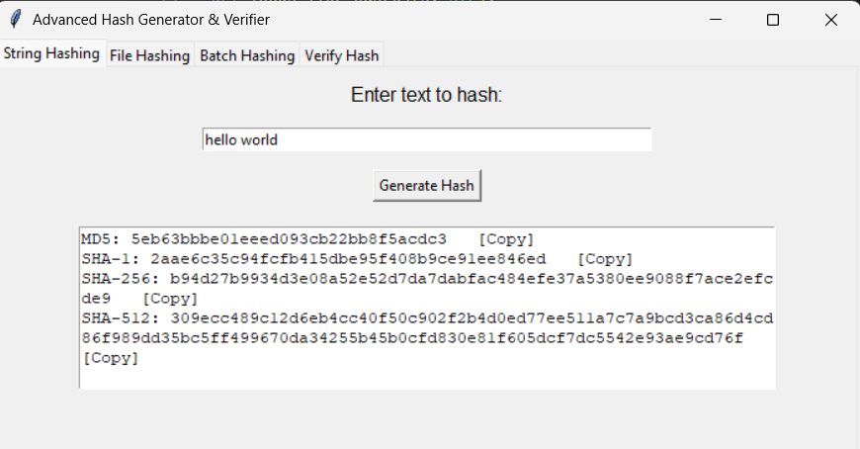

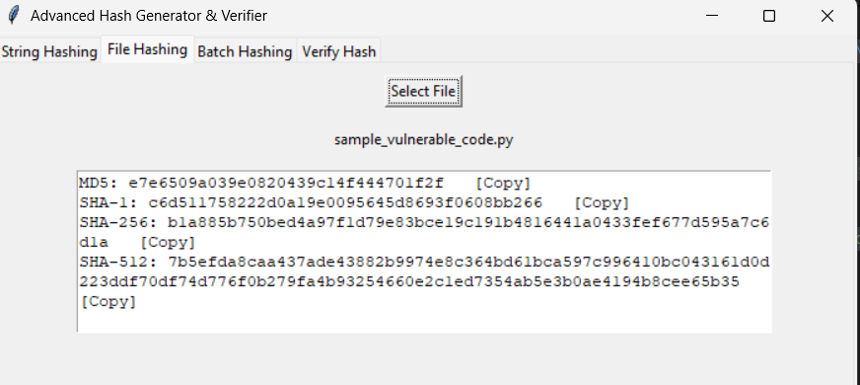

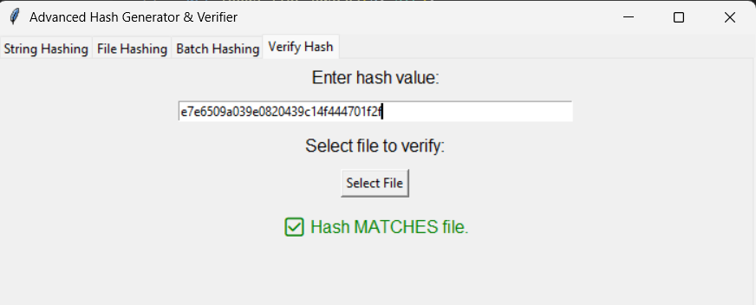

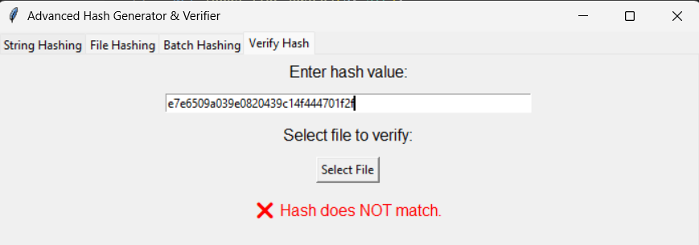

9 b. Explore obfuscation techniques.
Example: Create a simple obfuscation script that hides a Python function's logic.

CODE IMPLEMENTATION

import tkinter as tk
from tkinter import ttk, messagebox, filedialog
import base64
import binascii
import codecs
import urllib.parse
import pyperclip # pip install pyperclip
import string
import math

# -------------------------
# Safe obfuscation helpers
def b64_encode(s: str) -> str:
return base64.b64encode(s.encode('utf-8')).decode('utf-8')

def b64_decode(s: str):
try:
return base64.b64decode(s).decode('utf-8')
except Exception:
return None

def hex_encode(s: str) -> str:
return binascii.hexlify(s.encode('utf-8')).decode('utf-8')

def hex_decode(s: str):
try:
return binascii.unhexlify(s).decode('utf-8')
except Exception:
return None

def rot13(s: str) -> str:
return codecs.decode(s, 'rot_13')

def xor_obfuscate(s: str, key: int) -> str:
# return hex string of XORed bytes
b = s.encode('utf-8')
x = bytes([bb ^ key for bb in b])
return binascii.hexlify(x).decode('utf-8')

def xor_deobfuscate_from_hex(hexstr: str, key: int):
try:
data = binascii.unhexlify(hexstr)
x = bytes([bb ^ key for bb in data])
return x.decode('utf-8', errors='replace')
except Exception:
return None

def url_encode(s: str) -> str:
return urllib.parse.quote(s)

def url_decode(s: str) -> str:
try:
return urllib.parse.unquote(s)
except Exception:
return None

def whitespace_concat(s: str) -> str:
# split into small pieces with random-ish splits (deterministic here)
parts = [s[i:i+3] for i in range(0, len(s), 3)]
# return pieces joined with " + " to mimic concatenation obfuscation
return " + ".join([f"'{p}'" for p in parts])

def remove_concat_marks(s: str) -> str:
# Try to join simple quoted parts like 'abc' + 'def'
import re
parts = re.findall(r"'([^']*)'", s)
if parts:
return "".join(parts)
return None

# -------------------------
# Heuristics & detection helpers
def printable_ratio(s: str):
if not s:
return 0.0
printable = sum(1 for c in s if c in string.printable)
return printable / len(s)

def looks_like_base64(s: str):
# base64 uses A-Z a-z 0-9 +/ and = padding; reasonable length multiple of 4
import re
s_stripped = s.strip()
if len(s_stripped) % 4 != 0:
return False
return re.fullmatch(r'[A-Za-z0-9+/]+={0,2}', s_stripped) is not None

def looks_like_hex(s: str):
import re
s_stripped = s.strip()
return re.fullmatch(r'[0-9a-fA-F]+', s_stripped) is not None and len(s_stripped) % 2 == 0

def detection_score(s: str):
# simple weighted heuristic; 0..100 (higher -> more likely obfuscated)
score = 0.0
pr = printable_ratio(s)
if pr < 0.6:
score += 30
if looks_like_base64(s):
score += 30
if looks_like_hex(s):
score += 20
if '%' in s:
score += 10
if '\\x' in s or '0x' in s:
score += 10
# suspicious tokens commonly used in obfuscation wrappers
for token in ['eval(', 'Function(', 'unescape(', 'atob(', 'btoa(']:
if token in s:
score += 10
# clamp
return int(min(100, score))

# -------------------------
# GUI
class ObfuscationExplorer:
def __init__(self, root):
self.root = root
self.root.title("Obfuscation Explorer — Safe & Educational")
self.root.geometry("1000x700")
self._build_ui()

def _build_ui(self):
# Top: input and controls
top_frame = tk.Frame(self.root, pady=8)
top_frame.pack(fill='x')

tk.Label(top_frame, text="Input text:", font=("Segoe UI", 11)).grid(row=0, column=0, sticky='w')
self.input_box = tk.Text(top_frame, height=4, width=100, wrap='word', font=("Consolas", 11))
self.input_box.grid(row=1, column=0, columnspan=6, padx=8, pady=6)

tk.Button(top_frame, text="Clear", command=self.clear_input).grid(row=0, column=5, sticky='e', padx=6)
tk.Button(top_frame, text="Load from File...", command=self.load_file).grid(row=0, column=4, sticky='e', padx=6)

# Left: obfuscate actions
left = tk.LabelFrame(self.root, text="Obfuscate (apply)", padx=8, pady=8)
left.pack(side='left', fill='y', padx=10, pady=10)

tk.Button(left, text="Base64 Encode", width=20, command=self.do_b64).pack(pady=4)
tk.Button(left, text="Hex Encode", width=20, command=self.do_hex).pack(pady=4)
tk.Button(left, text="ROT13", width=20, command=self.do_rot13).pack(pady=4)
tk.Button(left, text="URL-Percent Encode", width=20, command=self.do_urlencode).pack(pady=4)

xor_frame = tk.Frame(left)
xor_frame.pack(pady=6)
tk.Label(xor_frame, text="XOR key (0-255):").pack(side='left')
self.xor_key_var = tk.IntVar(value=42)
tk.Entry(xor_frame, width=4, textvariable=self.xor_key_var).pack(side='left', padx=4)
tk.Button(xor_frame, text="XOR (hex output)", command=self.do_xor).pack(side='left', padx=6)

tk.Button(left, text="Whitespace / concat obfuscation", command=self.do_concat).pack(pady=6)

# Middle: outputs
mid = tk.LabelFrame(self.root, text="Output / Results", padx=8, pady=8)
mid.pack(side='left', fill='both', expand=True, padx=8, pady=10)

tk.Label(mid, text="Last Obfuscated Output:", font=("Segoe UI", 10, "bold")).pack(anchor='w')
self.output_box = tk.Text(mid, height=6, wrap='word', font=("Consolas", 11))
self.output_box.pack(fill='x', pady=6)
self.output_box.config(state='disabled')

copy_btn = tk.Button(mid, text="Copy Output", command=self.copy_output)
copy_btn.pack(anchor='e')

# Right: deobfuscate tries
right = tk.LabelFrame(self.root, text="Deobfuscate / Try decode", padx=8, pady=8)
right.pack(side='right', fill='y', padx=10, pady=10)

tk.Button(right, text="Try Base64 Decode", width=24, command=self.try_b64).pack(pady=4)
tk.Button(right, text="Try Hex Decode", width=24, command=self.try_hex).pack(pady=4)
tk.Button(right, text="Try ROT13", width=24, command=self.try_rot13).pack(pady=4)
tk.Button(right, text="URL Decode", width=24, command=self.try_urldecode).pack(pady=4)

tk.Label(right, text="Try XOR brute force (1-byte keys):").pack(pady=(8,0))
tk.Button(right, text="Run XOR brute (show printable results)", width=28, command=self.try_xor_bruteforce).pack(pady=4)

tk.Button(right, text="Try remove concat marks", width=28, command=self.try_remove_concat).pack(pady=6)

# Bottom: detection, deobfuscation attempts log
bottom = tk.LabelFrame(self.root, text="Detection & Deobfuscation Log", padx=8, pady=8)
bottom.pack(fill='both', expand=True, padx=10, pady=(0,10))

self.log_box = tk.Text(bottom, height=12, wrap='word', font=("Consolas", 11))
self.log_box.pack(fill='both', expand=True)
self.log_box.config(state='disabled')

# initial tip
self.log("Tip: Enter text above, click obfuscation buttons to see transformed output. Use 'Try ...' buttons to attempt deobfuscation.")

# -------------------------
# UI actions
def clear_input(self):
self.input_box.delete("1.0", tk.END)
self.output_box.config(state='normal')
self.output_box.delete("1.0", tk.END)
self.output_box.config(state='disabled')
self.log("Cleared input and output.")

def load_file(self):
path = filedialog.askopenfilename(title="Select file to load text from")
if not path:
return
try:
with open(path, 'r', encoding='utf-8', errors='ignore') as f:
data = f.read()
self.input_box.delete("1.0", tk.END)
self.input_box.insert(tk.END, data)
self.log(f"Loaded file: {path}")
except Exception as e:
messagebox.showerror("Error", f"Could not load file: {e}")

def _get_input(self):
return self.input_box.get("1.0", tk.END).rstrip("\n")

def _set_output(self, text):
self.output_box.config(state='normal')
self.output_box.delete("1.0", tk.END)
self.output_box.insert(tk.END, text)
self.output_box.config(state='disabled')

def copy_output(self):
out = self.output_box.get("1.0", tk.END).strip()
if out:
pyperclip.copy(out)
self.log("Output copied to clipboard.")
else:
messagebox.showinfo("Nothing", "No output to copy.")

def log(self, msg):
self.log_box.config(state='normal')
self.log_box.insert(tk.END, f"{msg}\n")
self.log_box.see(tk.END)
self.log_box.config(state='disabled')

# -------------------------
# Obfuscation actions
def do_b64(self):
s = self._get_input()
if not s:
messagebox.showwarning("Input needed", "Please enter text to obfuscate.")
return
out = b64_encode(s)
self._set_output(out)
self.log(f"[Base64] Encoded. Printable ratio {printable_ratio(out):.2f}. Detection score {detection_score(out)}")

def do_hex(self):
s = self._get_input()
if not s:
messagebox.showwarning("Input needed", "Please enter text to obfuscate.")
return
out = hex_encode(s)
self._set_output(out)
self.log(f"[Hex] Encoded. Length {len(out)}. Detection score {detection_score(out)}")

def do_rot13(self):
s = self._get_input()
if not s:
messagebox.showwarning("Input needed", "Please enter text to obfuscate.")
return
out = rot13(s)
self._set_output(out)
self.log("[ROT13] Applied.")

def do_urlencode(self):
s = self._get_input()
if not s:
messagebox.showwarning("Input needed", "Please enter text to obfuscate.")
return
out = url_encode(s)
self._set_output(out)
self.log("[URL-Percent] Encoded. Detection score %d" % detection_score(out))

def do_xor(self):
s = self._get_input()
if not s:
messagebox.showwarning("Input needed", "Please enter text to obfuscate.")
return
key = self.xor_key_var.get()
if not (0 <= key <= 255):
messagebox.showwarning("Key error", "XOR key must be 0-255")
return
out = xor_obfuscate(s, key)
self._set_output(out)
self.log(f"[XOR] Obfuscated with key {key}. Hex length {len(out)}. Try brute-force in Deobfuscate tab.")

def do_concat(self):
s = self._get_input()
if not s:
messagebox.showwarning("Input needed", "Please enter text to obfuscate.")
return
out = whitespace_concat(s)
self._set_output(out)
self.log("[Concat] Applied naive split+joint obfuscation.")

# -------------------------
# Deobfuscation tries
def try_b64(self):
s = self._get_input() or self.output_box.get("1.0", tk.END).strip()
if not s:
messagebox.showwarning("Input needed", "Please enter or produce some text to try decoding.")
return
if not looks_like_base64(s):
self.log("[Base64] Input does not look like canonical base64. Still attempting decode...")
res = b64_decode(s)
if res is None:
self.log("[Base64] decode failed or produced non-text.")
else:
self.log("[Base64] Success. Result preview:\n" + res[:100])

def try_hex(self):
s = self._get_input() or self.output_box.get("1.0", tk.END).strip()
if not s:
messagebox.showwarning("Input needed", "Please enter or produce some text to try decoding.")
return
if not looks_like_hex(s):
self.log("[Hex] Input doesn't look like pure hex; still attempting decode...")
res = hex_decode(s)
if res is None:
self.log("[Hex] decode failed.")
else:
self.log("[Hex] Success. Result preview:\n" + res[:200])

def try_rot13(self):
s = self._get_input() or self.output_box.get("1.0", tk.END).strip()
if not s:
messagebox.showwarning("Input needed", "Please enter or produce some text to try ROT13.")
return
self.log("[ROT13] Result preview:\n" + rot13(s)[:200])

def try_urldecode(self):
s = self._get_input() or self.output_box.get("1.0", tk.END).strip()
if not s:
messagebox.showwarning("Input needed", "Please enter or produce some text to try URL decode.")
return
res = url_decode(s)
if res is None:
self.log("[URLDecode] decode failed.")
else:
self.log("[URLDecode] Result preview:\n" + res[:200])

def try_xor_bruteforce(self):
s = self._get_input() or self.output_box.get("1.0", tk.END).strip()
if not s:
messagebox.showwarning("Input needed", "Please enter hex text (XORed output) to try brute force.")
return
if not looks_like_hex(s):
self.log("[XOR Bruteforce] Input does not look like hex — convert to hex first or select XOR output.")
# still attempt by treating raw bytes
candidates = []
for key in range(0, 256):
try:
out = xor_deobfuscate_from_hex(s, key)
# consider "likely readable" if printable ratio > 0.8 and has a space
pr = printable_ratio(out)
if pr > 0.8 and ' ' in out:
candidates.append((key, out[:200]))
except Exception:
continue
if not candidates:
self.log("[XOR Bruteforce] No high-confidence plaintext candidates found (showing low-confidence attempts):")
# show some attempts
for key in range(0, 10):
out = xor_deobfuscate_from_hex(s, key)
if out is not None:
self.log(f" key={key}: {out[:120]}")
else:
self.log("[XOR Bruteforce] Found plausible candidates:")
for key, out in candidates[:8]:
self.log(f" key={key}: {out}")

def try_remove_concat(self):
s = self._get_input() or self.output_box.get("1.0", tk.END).strip()
if not s:
messagebox.showwarning("Input needed", "Please enter or produce some text to try concat removal.")
return
res = remove_concat_marks(s)
if res:
self.log("[Concat removal] Success. Result:\n" + res[:200])
else:
self.log("[Concat removal] No simple quoted parts found.")

# -------------------------
if __name__ == "__main__":
root = tk.Tk()
app = ObfuscationExplorer(root)
root.mainloop()

RESULTS

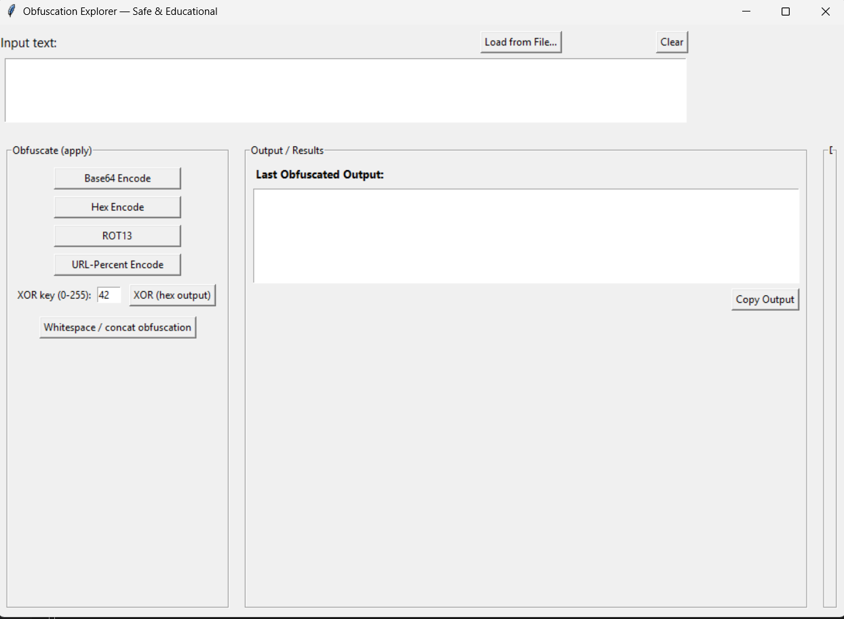

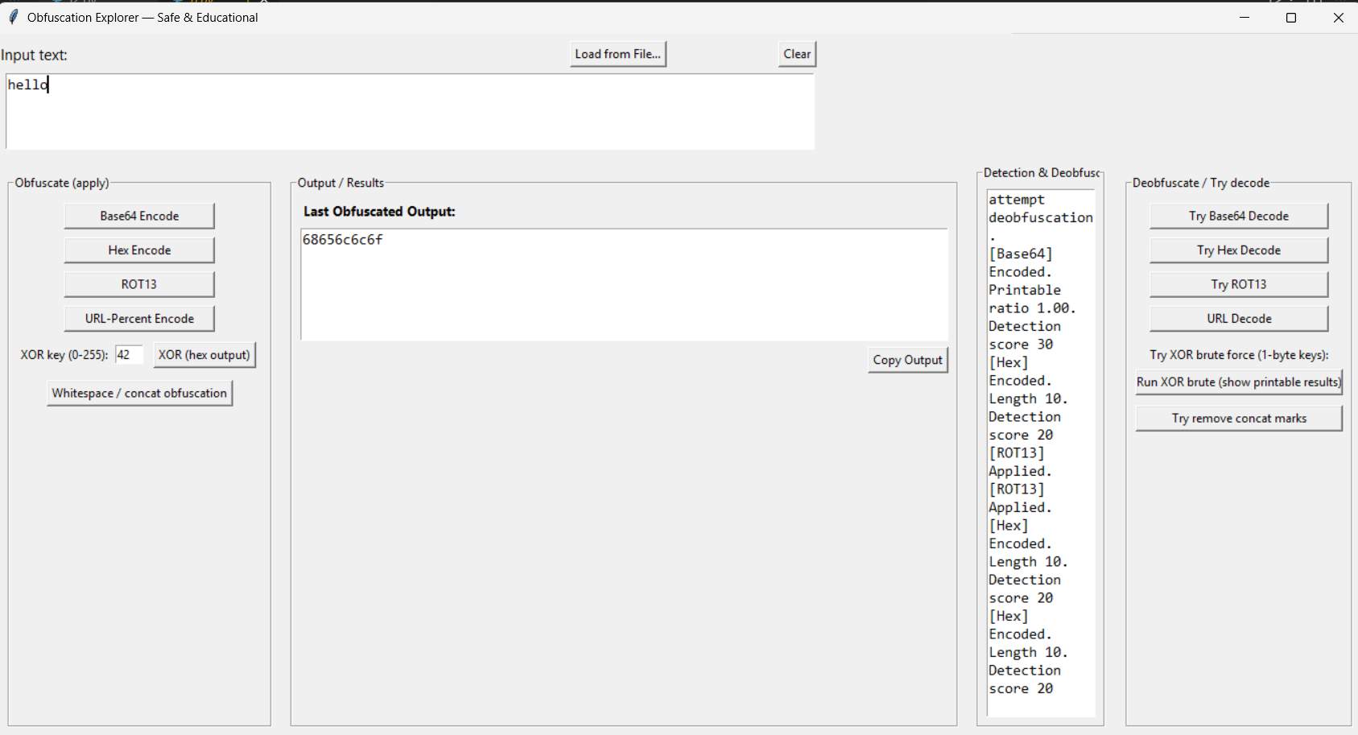

10 a. Implement digital signature generation and verification using RSA. o Use cryptography or PyCrypto libraries

CODE IMPLEMENTATION
A)
import tkinter as tk
from tkinter import filedialog, messagebox import base64
from cryptography.hazmat.primitives import hashes, serialization from cryptography.hazmat.primitives.asymmetric import rsa, padding from cryptography.hazmat.backends import default_backend

# --- RSA helpers --- def generate_keys():
private_key = rsa.generate_private_key(public_exponent=65537, key_size=2048, backend=default_backend())
public_key = private_key.public_key()

with open("private_key.pem", "wb") as f: f.write(private_key.private_bytes(
encoding=serialization.Encoding.PEM, format=serialization.PrivateFormat.TraditionalOpenSSL, encryption_algorithm=serialization.NoEncryption()
))
with open("public_key.pem", "wb") as f: f.write(public_key.public_bytes(
encoding=serialization.Encoding.PEM, format=serialization.PublicFormat.SubjectPublicKeyInfo
))
messagebox.showinfo("Keys Generated", "Saved as private_key.pem and public_key.pem")

def load_private_key():
with open("private_key.pem", "rb") as f:
return serialization.load_pem_private_key(f.read(), password=None, backend=default_backend())

def load_public_key():
with open("public_key.pem", "rb") as f:
return serialization.load_pem_public_key(f.read(), backend=default_backend())

def sign_message():
msg = entry_message.get("1.0", tk.END).strip().encode() if not msg:
messagebox.showerror("Error", "Enter a message to sign") return
try:
priv = load_private_key() sig = priv.sign(
msg,
padding.PSS(mgf=padding.MGF1(hashes.SHA256()), salt_length=padding.PSS.MAX_LENGTH), hashes.SHA256()
)
signature_b64.set(base64.b64encode(sig).decode()) except Exception as e:
messagebox.showerror("Error", f"Failed to sign: {e}")

def verify_signature():

msg = entry_message.get("1.0", tk.END).strip().encode() sig = signature_b64.get().strip()
if not msg or not sig:
messagebox.showerror("Error", "Need message and signature") return
try:
pub = load_public_key() pub.verify(
base64.b64decode(sig), msg,
padding.PSS(mgf=padding.MGF1(hashes.SHA256()), salt_length=padding.PSS.MAX_LENGTH), hashes.SHA256()
)
messagebox.showinfo("Verification", "Signature is VALID ⬛ ") except Exception:
messagebox.showerror("Verification", "Signature is INVALID +")
# --- GUI setup --- root = tk.Tk()
root.title("RSA Digital Signature (GUI)")

frame = tk.Frame(root, padx=10, pady=10) frame.pack()

btn_gen = tk.Button(frame, text="Generate Keys", command=generate_keys, bg="lightblue") btn_gen.grid(row=0, column=0, columnspan=2, pady=5)
tk.Label(frame, text="Message:").grid(row=1, column=0, sticky="w") entry_message = tk.Text(frame, height=5, width=40) entry_message.grid(row=2, column=0, columnspan=2, pady=5)

btn_sign = tk.Button(frame, text="Sign Message", command=sign_message, bg="lightgreen") btn_sign.grid(row=3, column=0, pady=5)

btn_verify = tk.Button(frame, text="Verify Signature", command=verify_signature, bg="orange") btn_verify.grid(row=3, column=1, pady=5)
tk.Label(frame, text="Signature (base64):").grid(row=4, column=0, sticky="w") signature_b64 = tk.StringVar()
entry_sig = tk.Entry(frame, textvariable=signature_b64, width=50) entry_sig.grid(row=5, column=0, columnspan=2, pady=5)
root.mainloop()

RESULTS

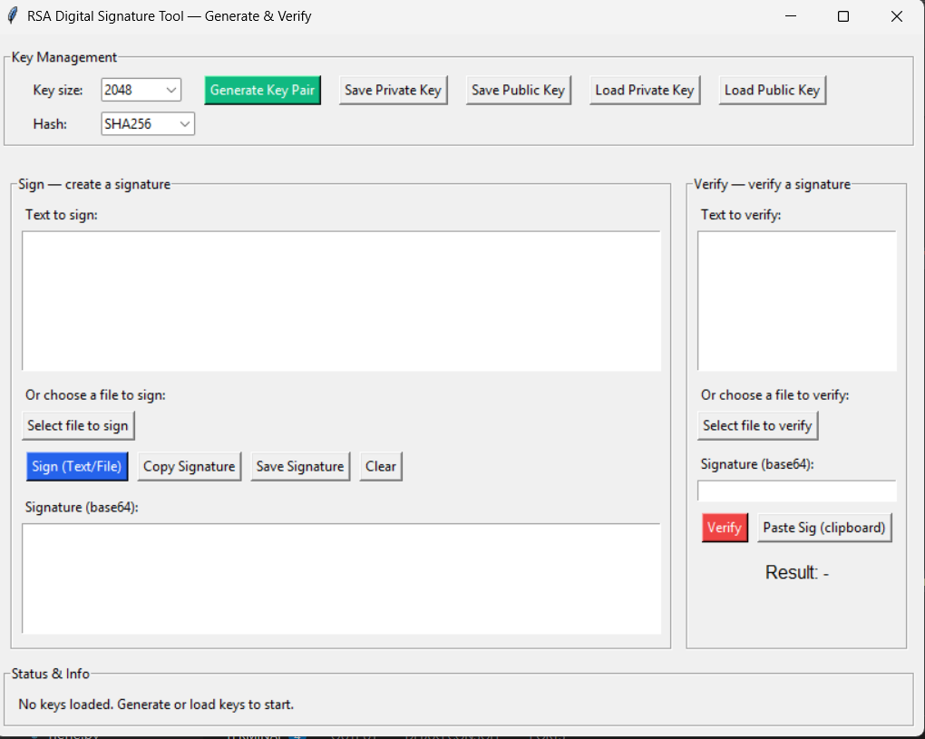
10 b. Simulate authentication and authorization using a web application (e.g., Flask or Django).Implement login functionality and secure API calls with tokens (e.g., JWT).

CODE IMPLEMENTATION

A) APP.PY

from flask import Flask, request, jsonify
from werkzeug.security import generate_password_hash, check_password_hash
from functools import wraps
import jwt, datetime, random
from flask_cors import CORS

app = Flask(__name__)
CORS(app)

JWT_SECRET = "change_this_super_secret_in_prod"
JWT_ALGO = "HS256"
JWT_EXP_MINUTES = 60

# In-memory user database
USERS = {
"admin": {"password_hash": generate_password_hash("adminpass"), "role": "admin"},
"user": {"password_hash": generate_password_hash("userpass"), "role": "user"}
}

# Temporary OTP store {username: otp}
OTP_STORE = {}

# JWT helpers
def create_token(username, role):
payload = {
"sub": username,
"role": role,
"exp": datetime.datetime.utcnow() + datetime.timedelta(minutes=JWT_EXP_MINUTES)
}
return jwt.encode(payload, JWT_SECRET, algorithm=JWT_ALGO)

def decode_token(token):
return jwt.decode(token, JWT_SECRET, algorithms=[JWT_ALGO])

# Auth decorators
def auth_required(f):
@wraps(f)
def wrapper(*args, **kwargs):
auth = request.headers.get("Authorization", "")
if not auth.startswith("Bearer "):
return jsonify({"error": "Missing Bearer token"}), 401
token = auth.split()[1]
try:
payload = decode_token(token)
request.user = payload
except Exception as e:
return jsonify({"error": "Invalid or expired token", "detail": str(e)}), 401
return f(*args, **kwargs)
return wrapper

def role_required(role):
def decorator(f):
@wraps(f)
def wrapper(*args, **kwargs):
if request.user.get("role") != role:
return jsonify({"error": "Forbidden"}), 403
return f(*args, **kwargs)
return wrapper
return decorator

# Routes
@app.route("/register", methods=["POST"])
def register():
data = request.json
username, password = data.get("username"), data.get("password")
if username in USERS:
return jsonify({"error": "User exists"}), 400
USERS[username] = {"password_hash": generate_password_hash(password), "role": "user"}
return jsonify({"ok": True, "msg": "User registered"})

@app.route("/login", methods=["POST"])
def login():
data = request.json
username, password = data.get("username"), data.get("password")
user = USERS.get(username)
if not user or not check_password_hash(user["password_hash"], password):
return jsonify({"error": "Invalid credentials"}), 401

# Generate OTP
otp = str(random.randint(100000, 999999))
OTP_STORE[username] = otp
return jsonify({"msg": f"OTP generated. Your OTP is {otp}. Enter it to continue."})

@app.route("/verify-otp", methods=["POST"])
def verify_otp():
data = request.json
username, otp = data.get("username"), data.get("otp")
stored = OTP_STORE.get(username)

if not stored or otp != stored:
return jsonify({"error": "Invalid OTP"}), 401

del OTP_STORE[username]
role = USERS[username]["role"]
token = create_token(username, role)
return jsonify({"access_token": token, "msg": "Login successful!", "role": role})

@app.route("/profile")
@auth_required
def profile():
return jsonify({
"username": request.user["sub"],
"role": request.user["role"],
"welcome_msg": f"Welcome, {request.user['sub']}!"
})

@app.route("/admin")
@auth_required
@role_required("admin")
def admin_area():
return jsonify({
"msg": "Welcome, admin! Here are admin-specific resources.",
"admin_data": ["User stats", "System logs", "Manage users"]
})

@app.route("/admin/users")
@auth_required
@role_required("admin")
def admin_users():
users_list = [{"username": u, "role": info["role"]} for u, info in USERS.items()]
return jsonify({"users": users_list})

if __name__ == "__main__":
app.run(port=5000, debug=True)

B) client.html

<!DOCTYPE html>
<html lang="en">
<head>
<meta charset="UTF-8">
<meta name="viewport" content="width=device-width, initial-scale=1.0">
<title>JWT Auth Client</title>
<style>
body { font-family: Arial; background: #eef0f3; margin: 0; padding: 0; }
.main { padding: 40px; max-width: 900px; margin: auto; }
h2 { color: #333; }
input { width: 100%; padding: 12px; margin: 10px 0; border: 1px solid #ccc; border-radius: 6px; font-size: 16px; }
button { padding: 12px 20px; margin: 8px 5px; border: none; border-radius: 6px; font-size: 15px; cursor: pointer; background: #5a6d7c; color: white; }
button:hover { background: #44525f; }
#messageBox { margin-top: 20px; background: #fefefe; border: 2px solid #ccc; padding: 15px; border-radius: 6px; font-size: 20px; font-weight: bold; min-height: 60px; }
#roleContent { margin-top: 30px; padding: 20px; background: #fff; border-radius: 6px; border: 1px solid #ccc; }
#adminData { margin-top: 15px; }
</style>
</head>
<body>
<div class="main">
<h2>Register / Login with OTP + JWT</h2>
<input type="text" id="username" placeholder="Username">
<input type="password" id="password" placeholder="Password">

<div>
<button onclick="register()">Register</button>
<button onclick="login(event)">Login (Get OTP)</button>
</div>

<input type="text" id="otp" placeholder="Enter OTP">
<button onclick="verifyOtp()">Verify OTP</button>

<div id="messageBox">Messages will appear here...</div>
<div id="roleContent"></div>
</div>

<script>
const API_URL = "http://127.0.0.1:5000";
let token = null;

function showMessage(data, force=false) {
let msg = "";
if (typeof data === "string") msg = data;
else if (data.msg) msg = "📢 " + data.msg;
else if (data.error) msg = "❌ Error: " + data.error;
else if (data.access_token) msg = "✅ Login successful! Token generated.";
else msg = JSON.stringify(data, null, 2);
document.getElementById("messageBox").textContent = msg;
}

async function register() {
const u = document.getElementById("username").value;
const p = document.getElementById("password").value;
const res = await fetch(`${API_URL}/register`, {
method: "POST",
headers: { "Content-Type": "application/json" },
body: JSON.stringify({ username: u, password: p })
});
showMessage(await res.json(), true);
}

async function login(event) {
event.preventDefault();
const u = document.getElementById("username").value;
const p = document.getElementById("password").value;
const res = await fetch(`${API_URL}/login`, {
method: "POST",
headers: { "Content-Type": "application/json" },
body: JSON.stringify({ username: u, password: p })
});
const data = await res.json();
showMessage(data, true);
if (data.msg && data.msg.includes("OTP")) document.getElementById("otp").focus();
}

async function verifyOtp() {
const u = document.getElementById("username").value;
const otp = document.getElementById("otp").value;
const res = await fetch(`${API_URL}/verify-otp`, {
method: "POST",
headers: { "Content-Type": "application/json" },
body: JSON.stringify({ username: u, otp })
});
const data = await res.json();
if (data.access_token) {
token = data.access_token;

// Fetch profile to get role
const profileRes = await fetch(`${API_URL}/profile`, {
headers: { "Authorization": `Bearer ${token}` }
});
const profileData = await profileRes.json();
showMessage(data, true);

const roleDiv = document.getElementById("roleContent");
if(profileData.role === "admin") {
roleDiv.innerHTML = `
<h3>Admin Dashboard</h3>
<p>Welcome, ${profileData.username}! You have admin privileges.</p>
<button onclick="getAdmin()">View Admin Resources</button>
<button onclick="getAllUsers()">View All Users</button>
<div id="adminData"></div>
`;
} else {
roleDiv.innerHTML = `
<h3>User Dashboard</h3>
<p>Welcome, ${profileData.username}! You have regular user access.</p>
`;
}
} else {
showMessage(data, true);
}
}

async function getAdmin() {
if (!token) return alert("Login first!");
const res = await fetch(`${API_URL}/admin`, {
headers: { "Authorization": `Bearer ${token}` }
});
const data = await res.json();
const adminDiv = document.getElementById("adminData");
adminDiv.innerHTML = `<pre>${JSON.stringify(data, null, 2)}</pre>`;
}

async function getAllUsers() {
if (!token) return alert("Login first!");
const res = await fetch(`${API_URL}/admin/users`, {
headers: { "Authorization": `Bearer ${token}` }
});
const data = await res.json();
const adminDiv = document.getElementById("adminData");
if(data.users) {
adminDiv.innerHTML = `<h4>Registered Users:</h4><ul>${data.users.map(u => `<li>${u.username} (${u.role})</li>`).join("")}</ul>`;
} else {
adminDiv.innerHTML = `<p>No users found.</p>`;
}
}
</script>
</body>
</html>

C) Client_gui.py
import tkinter as tk
from tkinter import messagebox
import requests

API_URL = "http://127.0.0.1:5000"
token = None # store JWT here

def register_user():
u, p = entry_user.get(), entry_pass.get()
if not u or not p:
messagebox.showerror("Error", "Enter username & password")
return
r = requests.post(f"{API_URL}/register", json={"username": u, "password": p})
text_output.delete("1.0", tk.END)
text_output.insert(tk.END, r.text)

def login_user():
global token
u, p = entry_user.get(), entry_pass.get()
r = requests.post(f"{API_URL}/login", json={"username": u, "password": p})
data = r.json()
text_output.delete("1.0", tk.END)
text_output.insert(tk.END, str(data))
if "access_token" in data:
token = data["access_token"]

def get_profile():
if not token:
messagebox.showerror("Error", "Login first!")
return
r = requests.get(f"{API_URL}/profile", headers={"Authorization": f"Bearer {token}"})
text_output.delete("1.0", tk.END)
text_output.insert(tk.END, r.text)

def get_admin():
if not token:
messagebox.showerror("Error", "Login first!")
return
r = requests.get(f"{API_URL}/admin", headers={"Authorization": f"Bearer {token}"})
text_output.delete("1.0", tk.END)
text_output.insert(tk.END, r.text)

# --- GUI setup ---
root = tk.Tk()
root.title("JWT Auth Client")

frame = tk.Frame(root, padx=10, pady=10)
frame.pack()

tk.Label(frame, text="Username:").grid(row=0, column=0)
entry_user = tk.Entry(frame, width=20)
entry_user.grid(row=0, column=1)

tk.Label(frame, text="Password:").grid(row=1, column=0)
entry_pass = tk.Entry(frame, width=20, show="*")
entry_pass.grid(row=1, column=1)

tk.Button(frame, text="Register", command=register_user, bg="lightblue").grid(row=2, column=0, pady=5)
tk.Button(frame, text="Login", command=login_user, bg="lightgreen").grid(row=2, column=1, pady=5)
tk.Button(frame, text="Profile", command=get_profile, bg="orange").grid(row=3, column=0, pady=5)
tk.Button(frame, text="Admin", command=get_admin, bg="red").grid(row=3, column=1, pady=5)

text_output = tk.Text(frame, height=10, width=50)
text_output.grid(row=4, column=0, columnspan=2, pady=10)

root.mainloop()

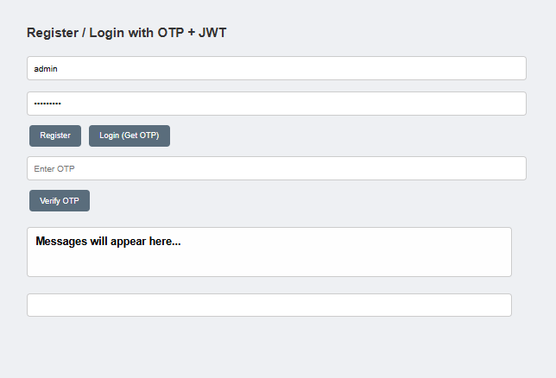

OR

RESULTS

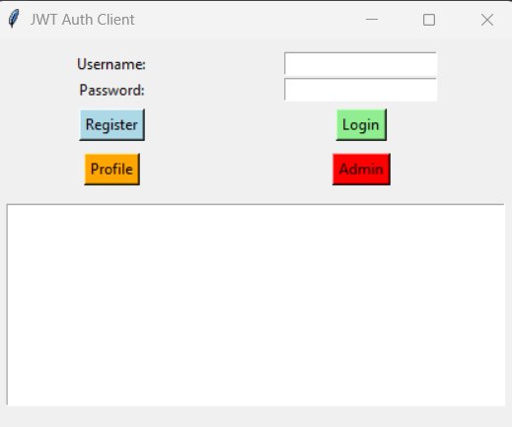
Login - user

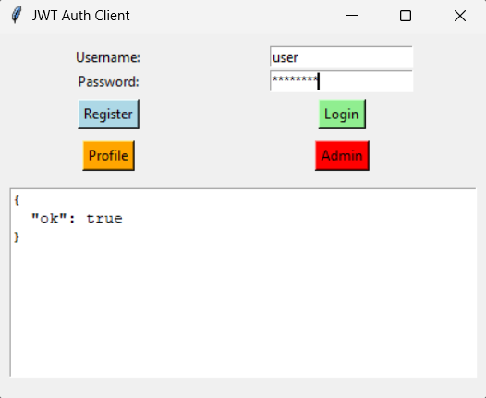

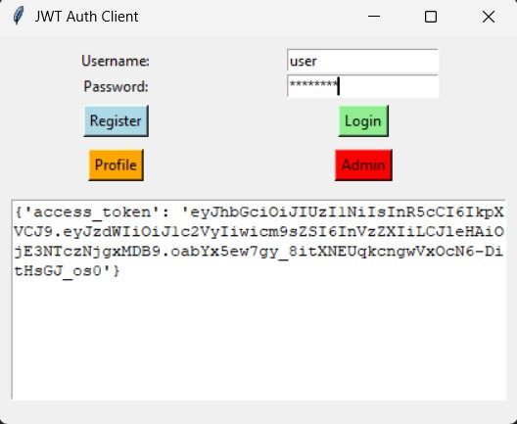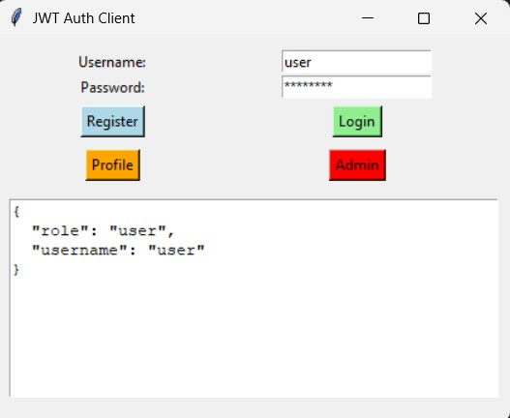

Login - admin
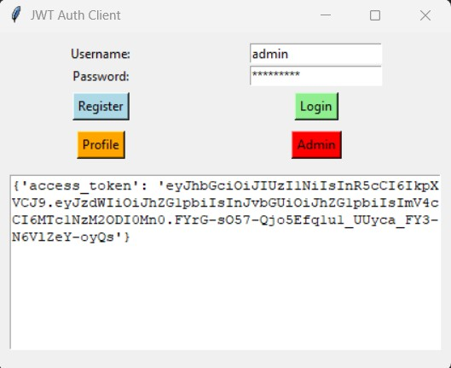
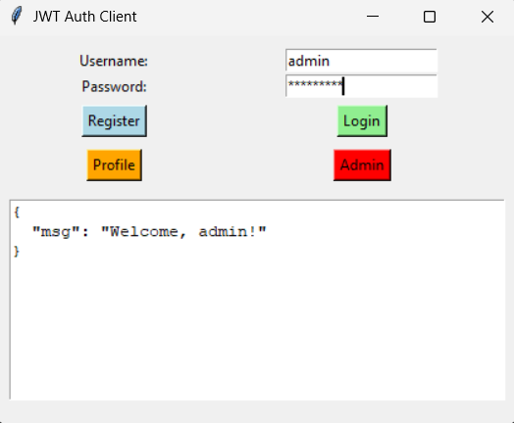
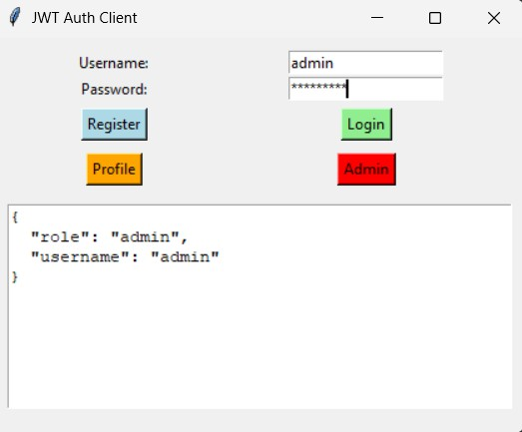
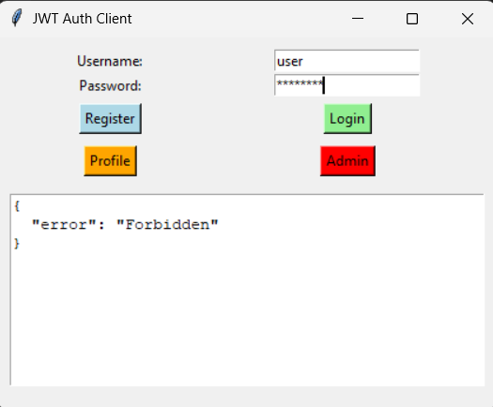

11 a Identifying and Classifying PII Data: Given a dataset, students will write a script to classify data into types (structured/unstructured), states (in-transit, at-rest, in-use), and highlight PII elements.

CODE IMPLEMENTATION

import tkinter as tk
from tkinter import filedialog, messagebox, ttk
import pandas as pd
import re
import os
import requests
from io import StringIO

# ------------------- PII Patterns -------------------
PII_PATTERNS = {
"Email": r'[a-zA-Z0-9_.+-]+@[a-zA-Z0-9-]+\.[a-zA-Z0-9-.]+',
"Phone": r'\b\d{10}\b',
"Aadhaar": r'\b\d{4}\s?\d{4}\s?\d{4}\b',
"PAN": r'[A-Z]{5}\d{4}[A-Z]{1}',
"Name": r'\b[A-Z][a-z]+ [A-Z][a-z]+\b'
}

class PIIDetectorApp:
def __init__(self, root):
self.root = root
self.root.title("PII Data Classification Tool")
self.root.geometry("950x600")
self.root.configure(bg="#f5f7fa")

# Title
tk.Label(root, text="🔍 Intelligent PII Data Classification Tool",
font=("Arial", 20, "bold"), bg="#f5f7fa", fg="#333").pack(pady=15)

# Input section
self.url_entry = tk.Entry(root, font=("Arial", 12), width=50)
self.url_entry.pack(pady=5)
self.url_entry.insert(0, "Enter dataset URL (optional)")

tk.Button(root, text="Load from URL", command=self.load_from_url,
bg="#4c8bf5", fg="white", font=("Arial", 12)).pack(pady=5)

tk.Button(root, text="Upload Local File (CSV/TXT)", command=self.upload_file,
bg="#2f9e44", fg="white", font=("Arial", 12)).pack(pady=10)

# Results area
self.text_area = tk.Text(root, wrap="word", font=("Consolas", 11), height=20)
self.text_area.pack(fill='both', expand=True, padx=20, pady=15)

# ------------------- Detect from URL (In Transit) -------------------
def load_from_url(self):
url = self.url_entry.get().strip()
if not url.startswith("http"):
messagebox.showerror("Invalid URL", "Please enter a valid URL (starting with http/https).")
return
try:
response = requests.get(url)
response.raise_for_status()
if url.endswith(".csv"):
df = pd.read_csv(StringIO(response.text), nrows=100)
self.analyze_structured_data(df, "In Transit")
else:
text = response.text
self.analyze_unstructured_data(text, "In Transit")
except Exception as e:
messagebox.showerror("Error", f"Failed to fetch data: {e}")

# ------------------- Detect from Local File (At Rest) -------------------
def upload_file(self):
file_path = filedialog.askopenfilename(filetypes=[("CSV files","*.csv"),("Text files","*.txt")])
if not file_path:
return

ext = os.path.splitext(file_path)[1].lower()
try:
if ext == ".csv":
data = pd.read_csv(file_path, nrows=100)
self.analyze_structured_data(data, "At Rest")
elif ext == ".txt":
with open(file_path, "r", encoding="utf-8") as f:
text = f.read()
self.analyze_unstructured_data(text, "At Rest")
except Exception as e:
messagebox.showerror("Error", f"Failed to read file: {e}")

# ------------------- Structured Data Analysis -------------------
def analyze_structured_data(self, df, state):
result = ["✅ Data Type: Structured"]
result.append(f"✅ Data State: {state}")

# Once analyzed, it's "In Use"
result.append("⚙️ Data is currently being processed → In Use")

pii_found = False
for col in df.columns:
col_data = df[col].astype(str).str.cat(sep=' ')
for key, pattern in PII_PATTERNS.items():
if re.search(pattern, col_data):
result.append(f"⚠️ PII Detected: {key} found in column '{col}'")
pii_found = True

if not pii_found:
result.append("✔️ No PII Detected in structured dataset.")

self.display_result(result)

# ------------------- Unstructured Data Analysis -------------------
def analyze_unstructured_data(self, text, state):
result = ["✅ Data Type: Unstructured"]
result.append(f"✅ Data State: {state}")
result.append("⚙️ Data is currently being processed → In Use")

pii_found = False
for key, pattern in PII_PATTERNS.items():
matches = re.findall(pattern, text)
if matches:
result.append(f"⚠️ PII Detected: {key} ({len(matches)} instances)")
pii_found = True

if not pii_found:
result.append("✔️ No PII Detected in unstructured data.")

self.display_result(result)

def display_result(self, lines):
self.text_area.delete("1.0", tk.END)
self.text_area.insert(tk.END, "\n".join(lines))

if __name__ == "__main__":
root = tk.Tk()
app = PIIDetectorApp(root)
root.mainloop()

RESULT
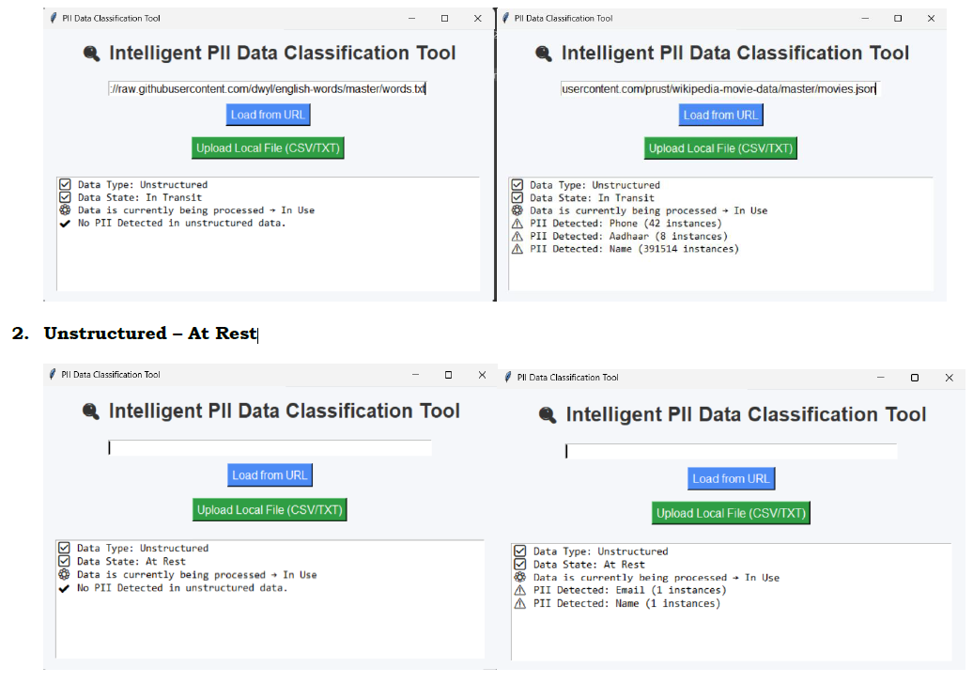

11 B Anonymization with k-Anonymity: Use a sample dataset with PII (like healthcare data). Apply k-anonymity using Python or tools like ARX. Evaluate re-identification risk before and after anonymization.

CODE IMPLEMENTATION

import streamlit as st
import pandas as pd
import numpy as np
import io

# ------------------------------
# Utility Functions
# ------------------------------

def generalize_zip(zipcode, level):
if pd.isna(zipcode): return zipcode
s = str(zipcode)
if level <= 0: return s
if level >= len(s): return "*" * len(s)
return s[:len(s) - level] + "*" * level

def generalize_age(age, bin_size):
if pd.isna(age): return age
# Ensure age is treated as a number for binning
try:
age = int(age)
except ValueError:
return age # Return as-is if conversion fails

start = (age // bin_size) * bin_size
return f"{start}-{start+bin_size-1}"

def equivalence_classes(df, quasi_identifiers):
"""
Return merged dataframe and grouped summary (counts per equivalence class).
"""
if not quasi_identifiers:
# Return empty grouped DataFrame with expected structure
grouped = pd.DataFrame(columns=quasi_identifiers + ["count"])
merged = df.copy()
merged["count"] = len(df)
return merged, grouped
grouped = df.groupby(quasi_identifiers).size().reset_index(name="count")
merged = df.merge(grouped, on=quasi_identifiers, how="left")
return merged, grouped

def reidentification_risk(df, quasi_identifiers):
"""
Computes re-identification risk metrics based on equivalence class sizes.
"""
if not quasi_identifiers:
n = len(df)
if n == 0:
return {"min_eq_size": 0, "avg_eq_size": 0, "naive_min_risk": 1.0, "unique_fraction": 0.0}
# If no QIs, the whole dataset is treated as one class
return {"min_eq_size": n, "avg_eq_size": float(n), "naive_min_risk": 1.0 / n, "unique_fraction": 0.0}

_, grouped = equivalence_classes(df, quasi_identifiers)

if grouped.empty and len(df) > 0:
# Defensive fallback if grouping produced nothing but data exists (e.g., all NaN QIs)
n = len(df)
return {"min_eq_size": n, "avg_eq_size": float(n), "naive_min_risk": 1.0 / n, "unique_fraction": 0.0}
elif grouped.empty and len(df) == 0:
return {"min_eq_size": 0, "avg_eq_size": 0, "naive_min_risk": 1.0, "unique_fraction": 0.0}

min_size = int(grouped["count"].min())
avg_size = float(grouped["count"].mean())
naive_min_risk = 1.0 / min_size if min_size > 0 else 1.0
unique_frac = (grouped["count"] == 1).sum() / len(df)

return {
"min_eq_size": min_size,
"avg_eq_size": avg_size,
"naive_min_risk": naive_min_risk,
"unique_fraction": unique_frac
}

def apply_k_anonymity(df, quasi_identifiers, k):
"""
Applies generalization to Age/Zip QIs until k-anonymity is met or limits are reached.
Returns the generalized DataFrame, the final risk stats, and the list of QI columns used for the check.
"""
df_work = df.copy()

def make_qis(d, zip_level, age_bin):
"""Helper to create generalized columns based on current levels."""
d = d.copy()
qi_cols_used = []

if "Zip" in quasi_identifiers and "Zip" in d.columns:
d["Zip_g"] = d["Zip"].apply(lambda z: generalize_zip(z, zip_level))
qi_cols_used.append("Zip_g")
elif "Zip" in quasi_identifiers and "Zip" not in d.columns:
# QI selected but not in data, ignore
pass
elif "Zip" in d.columns:
# Column in data but not QI, keep as-is
qi_cols_used.append("Zip")

if "Age" in quasi_identifiers and "Age" in d.columns:
# Handle potential non-numeric Age values by coercing
d["Age_g"] = d["Age"].apply(lambda a: generalize_age(a, age_bin))
qi_cols_used.append("Age_g")
elif "Age" in quasi_identifiers and "Age" not in d.columns:
pass
elif "Age" in d.columns:
qi_cols_used.append("Age")

# For other QIs, use the original column name if present
for q in quasi_identifiers:
if q not in ["Zip", "Age"] and q in d.columns:
qi_cols_used.append(q)

# Filter to unique columns for the check
return d, list(set(qi_cols_used))

# Initial generalization levels
zip_level = 0
age_bin = 5

# ---------------------------------------------
# Initial Check (level 0 generalization)
# ---------------------------------------------
zipped, risk_qis = make_qis(df_work, zip_level, age_bin)

# If no QIs were selected or found, return original data and single class stats
if not risk_qis:
stats = reidentification_risk(df_work, []) # Single equivalence class
return df_work, stats, []

stats = reidentification_risk(zipped, risk_qis)

# ---------------------------------------------
# Iterate generalization until k satisfied
# ---------------------------------------------
max_zip_level = 5 # 56001 -> 5600* -> 560** -> 56*** -> 5**** -> *****
max_age_bin = 80

while stats["min_eq_size"] < k:

# Determine the next step: generalize Zip first, then widen Age bins
if "Zip" in quasi_identifiers and zip_level < max_zip_level:
zip_level += 1
elif "Age" in quasi_identifiers and age_bin < max_age_bin:
# Double the bin size until max_age_bin
age_bin = min(age_bin * 2, max_age_bin)
else:
# no generalizable QIs left or limits reached -> break
break

# Apply new generalization levels and re-evaluate
zipped, risk_qis = make_qis(df_work, zip_level, age_bin)
stats = reidentification_risk(zipped, risk_qis)

# Final result: only include original columns plus the generalized ones (if created)
return zipped, stats, risk_qis

def l_diversity_check(df, quasi_identifiers, sensitive_attr, l):
if sensitive_attr not in df.columns:
return {"total_classes": 0, "failing_classes": 0, "failing_fraction": 0.0, "error": f"Sensitive attribute '{sensitive_attr}' not found."}

if not quasi_identifiers:
distinct_sens = df[sensitive_attr].nunique()
failing = 1 if distinct_sens < l else 0
return {"total_classes": 1, "failing_classes": failing, "failing_fraction": float(failing)}

merged = df.groupby(quasi_identifiers)[sensitive_attr].nunique().reset_index(name="distinct_sens")
failing = merged[merged["distinct_sens"] < l]

return {
"total_classes": len(merged),
"failing_classes": len(failing),
"failing_fraction": (len(failing) / len(merged)) if len(merged) > 0 else 0
}

def t_closeness_check(df, quasi_identifiers, sensitive_attr, t):
if sensitive_attr not in df.columns:
return {"num_classes": 0, "failing_classes": 0, "failing_fraction": 0.0, "error": f"Sensitive attribute '{sensitive_attr}' not found."}

if not quasi_identifiers:
# single class; TVD is 0
return {"num_classes": 1, "failing_classes": 0, "failing_fraction": 0.0}

# Global distribution of the sensitive attribute
global_dist = df[sensitive_attr].value_counts(normalize=True)
grouped = df.groupby(quasi_identifiers)

failing = 0
num_classes = 0

for _, group in grouped:
num_classes += 1
class_dist = group[sensitive_attr].value_counts(normalize=True)

# Union of indices to cover all possible values in the TVD calculation
all_idx = global_dist.index.union(class_dist.index)
gd = global_dist.reindex(all_idx, fill_value=0)
cd = class_dist.reindex(all_idx, fill_value=0)

# Total Variation Distance (TVD)
tvd = 0.5 * (gd - cd).abs().sum()

if tvd > t:
failing += 1

return {
"num_classes": num_classes,
"failing_classes": failing,
"failing_fraction": failing / num_classes if num_classes > 0 else 0
}

def apply_differential_privacy(df, numeric_cols, epsilon):
df2 = df.copy()
scale = 1.0 / epsilon # Laplace mechanism scale (sensitivity/epsilon, sensitivity assumed 1 for counts/sums)

for col in numeric_cols:
if col in df2.columns:
noise = np.random.laplace(0, scale, size=len(df2))

# Check if the column is primarily integer-based to round the noisy result
is_int = pd.api.types.is_integer_dtype(df2[col]) or all(float(x).is_integer() for x in df2[col].dropna())

if is_int:
# Add noise, round, and ensure result is within reasonable bounds (e.g., non-negative for age/counts)
df2[col + "_dp"] = (df2[col] + noise).round().clip(lower=0).astype(int)
else:
df2[col + "_dp"] = df2[col] + noise

return df2

# ------------------------------
# Streamlit UI
# ------------------------------

st.set_page_config(page_title="PII Anonymizer Advanced", layout="wide")
st.title("🔐 PII Anonymizer — Advanced Streamlit Demo")

st.write("Upload a CSV file containing PII-like data and apply privacy-preserving techniques.")

uploaded_file = st.file_uploader("Upload CSV dataset", type=["csv"])

if uploaded_file:
df_raw = pd.read_csv(uploaded_file)
st.subheader("📄 Original Dataset Preview")
st.dataframe(df_raw.head(10))
else:
st.info("Upload a CSV to begin, or use the sample dataset below.")
np.random.seed(42)
names = [f"Person_{i+1}" for i in range(20)]
# Create sample data
df_raw = pd.DataFrame({
"Name": names,
"Age": np.random.randint(20, 80, 20),
"Gender": np.random.choice(["M", "F"], 20),
"Zip": np.random.choice([56001, 56002, 56003, 56004, 56005], 20),
"Diagnosis": np.random.choice(["Flu", "Diabetes", "COVID", "Healthy"], 20)
})
st.dataframe(df_raw.head(10))

# ------------------------------
# Sidebar settings
# ------------------------------
st.sidebar.header("⚙️ Settings")

available_cols = df_raw.columns.tolist()

# Drop Direct PII (Name) if it exists in the raw data
df_anon = df_raw.copy()
if 'Name' in available_cols:
df_anon = df_anon.drop(columns=['Name'])
available_cols.remove('Name')
st.sidebar.caption("✅ 'Name' column (Direct PII) has been dropped for anonymization.")

# Update available columns after dropping 'Name'
current_cols = df_anon.columns.tolist()

# Safe defaults for QIs
default_qi = [c for c in ["Age", "Gender", "Zip"] if c in current_cols]
quasi_identifiers = st.sidebar.multiselect(
"Select Quasi-Identifiers (QI)",
current_cols,
default=default_qi
)

# Safe default for sensitive attribute
if "Diagnosis" in current_cols:
default_sensitive = "Diagnosis"
elif len(current_cols) > 0:
default_sensitive = current_cols[-1]
else:
default_sensitive = None

sensitive_attr = st.sidebar.selectbox(
"Select Sensitive Attribute",
current_cols,
index=current_cols.index(default_sensitive) if default_sensitive in current_cols else 0
)

# Safe numeric column detection
numeric_cols_all = [c for c in current_cols if pd.api.types.is_numeric_dtype(df_anon[c])]
default_numeric = [c for c in ["Age"] if c in numeric_cols_all]

numeric_cols = st.sidebar.multiselect(
"Numeric Columns for Differential Privacy",
numeric_cols_all,
default=default_numeric
)

# Privacy parameters
k = st.sidebar.slider("k (k-anonymity)", 2, 10, 3)
l = st.sidebar.slider("l (l-diversity)", 1, 5, 2)
t = st.sidebar.slider("t (t-closeness)", 0.0, 1.0, 0.25, step=0.05)
epsilon = st.sidebar.slider("ε (Differential Privacy)", 0.1, 5.0, 1.0, step=0.1)

# ------------------------------
# Apply button
# ------------------------------
if st.button("🔒 Apply Anonymization & Evaluate Risk", key="apply_btn_main"):
with st.spinner("Applying privacy techniques..."):

# 1. Evaluate risk before (using df_anon which has PII removed)
if not quasi_identifiers:
st.error("⚠️ Please select at least one quasi-identifier (QI) before applying anonymization.")
st.stop()

risk_before = reidentification_risk(df_anon, quasi_identifiers)

# 2. Apply k-anonymity (an_k contains generalized columns like Age_g, Zip_g)
# qi_cols_anonymized contains the generalized column names (e.g., 'Age_g', 'Zip_g', 'Gender')
an_k, stats_k, qi_cols_anonymized = apply_k_anonymity(df_anon, quasi_identifiers, k)

# 3. Evaluate l-diversity and t-closeness (on the k-anonymized data)
l_stats = l_diversity_check(an_k, qi_cols_anonymized, sensitive_attr, l)
t_stats = t_closeness_check(an_k, qi_cols_anonymized, sensitive_attr, t)

# 4. Apply differential privacy
an_dp = apply_differential_privacy(an_k, numeric_cols, epsilon)

# 5. Risk after (using the combined an_dp dataset and the generalized QI columns)
risk_after = reidentification_risk(an_dp, qi_cols_anonymized)

st.success("Anonymization Completed ✅")

st.subheader("📊 Risk Evaluation Comparison")
col1, col2 = st.columns(2)
with col1:
st.write("**Before Anonymization** (Risk based on original QIs)")
st.json(risk_before)
with col2:
st.write("**After Anonymization** (Risk based on generalized QIs: **{}**)".format(", ".join(qi_cols_anonymized)))
st.json(risk_after)

st.subheader("k-Anonymity & Diversity Metrics")
st.write(f"**Target k-Anonymity:** k={k} (Achieved minimum equivalence class size: **{stats_k['min_eq_size']}**)")
st.write("**k-Anonymity Stats (based on generalized data):**", stats_k)
st.write("**l-Diversity Stats (based on generalized data):**", l_stats)
st.write("**t-Closeness Stats (based on generalized data):**", t_stats)

st.subheader("🔍 Anonymized Dataset (Top 10 Rows)")
st.write("Contains original columns, generalized QI columns (e.g., `Age_g`, `Zip_g`), and differentially private columns (e.g., `Age_dp`).")
st.dataframe(an_dp.head(10))

# Download anonymized CSV
csv = an_dp.to_csv(index=False).encode('utf-8')
st.download_button("📥 Download Anonymized CSV", csv, "anonymized_dataset.csv", "text/csv")

st.markdown("---")
st.caption("Educational demo — for learning only. Use professional anonymization libraries for production.")

RESULT

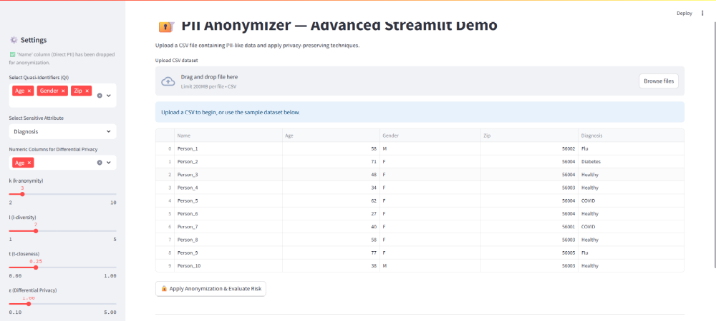

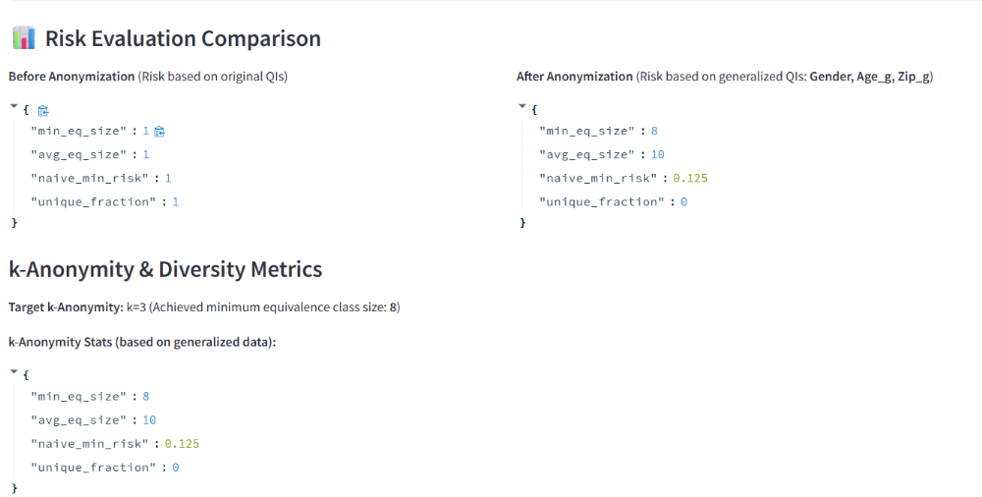
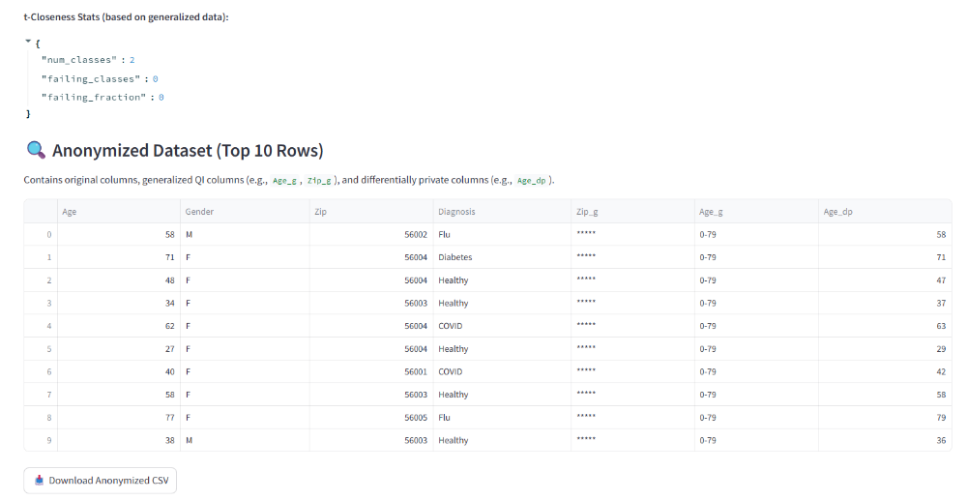

12. Case Study on GDPR and DPDP Act 2023: create a comparative chart of GDPR and DPDP Act 2023 principles and explain roles like Data Protection Officer (DPO). Include a mock incident report format.

The rapid digitization of personal, financial, health, and behavioral data has intensified the need for robust data protection and privacy regulations globally. The European Union’s General Data Protection Regulation (GDPR), implemented in May 2018, is considered a gold standard in personal data protection, influencing many global regulations. India, recognizing the critical importance of safeguarding digital personal data, enacted the Digital Personal Data Protection (DPDP) Act, 2023, to establish a legal framework regulating the collection, processing, storage, and sharing of digital personal data.
This case study provides a comprehensive comparative analysis of GDPR and the DPDP Act 2023, focusing on their principles, individual rights, compliance requirements, enforcement mechanisms, and key roles like the Data Protection Officer (DPO). The analysis highlights how both regulations address modern data processing challenges, enhance transparency, ensure accountability, and protect data subject rights. Understanding the similarities and differences aids organizations, policymakers, and researchers in achieving compliance and implementing best practices.

DATA PROTECTION OFFICER (DPO)
A Data Protection Officer (DPO) is a senior-level official responsible for ensuring that an organization processes personal data in compliance with data protection laws and regulations.
They act as an independent advisor and monitor within an organization to ensure lawful data collection, processing, storage, and sharing.The DPO also serves as a bridge between the organization, data subjects (individuals), and data protection authorities (regulators).
The DPO is not directly responsible for making business decisions, but ensures that those decisions comply with data protection principles.
The Data Protection Officer (DPO) is a mandatory role under the European Union’s General Data Protection Regulation (GDPR) and a recommended or conditional role under India’s Digital Personal Data Protection (DPDP) Act, 2023/2024.

Role and Responsibilities of DPO

Core Responsibilities under the GDPR
Under the European GDPR, the DPO’s role is comprehensive and strategic. The DPO must ensure that all data processing activities within the organization adhere to the core principles of lawfulness, fairness, transparency, purpose limitation, and accountability.

Key functions include:
- Monitoring Compliance: The DPO oversees the organization’s data protection framework, ensuring that all activities comply with the GDPR. This involves regular audits, policy reviews, and continuous risk assessments.

- Advisory Role: The DPO advises the management and employees on their legal obligations under GDPR. Before any new project or data processing activity is launched, the DPO evaluates its compliance implications and provides recommendations.

- Supervisory Authority Liaison: A critical responsibility is to act as the contact point between the organization and the national data protection authority. The DPO communicates with regulators, manages data breach notifications, and supports audits or investigations.

- Employee Awareness and Training: The DPO develops training programs to educate employees about data privacy obligations, cybersecurity awareness, and responsible data handling.

- Data Breach Response: In the event of a data breach, the DPO coordinates the organization’s response. This includes confirming the breach, assessing its impact, notifying the authority within 72 hours, and informing affected individuals if required.

- Documentation and Reporting: The DPO maintains detailed records of data processing activities, breach logs, and risk assessments, ensuring traceability and accountability.

Core Responsibilities under the DPDP Act 2023–2024
The Digital Personal Data Protection (DPDP) Act 2023–2024 introduces the role of the DPO primarily for Significant Data Fiduciaries (SDFs). While the DPO’s role under the Indian law mirrors several GDPR principles, it also includes user-centric functions and responsibilities unique to the Indian context.

- Ensuring Compliance: The DPO ensures that the organization complies with all obligations under the DPDP Act—particularly regarding lawful data processing, obtaining valid consent, and upholding user rights such as access, correction, and erasure.

- User Grievance Redressal: A distinctive feature of the Indian DPO’s role is the responsibility to act as the point of contact for data principals (users). The DPO must address grievances, provide explanations of data handling practices, and ensure that users receive timely redressal.

- Coordination with the Data Protection Board of India (DPBI): The DPO represents the organization in all communications with the DPBI. This includes responding to compliance inquiries, breach investigations, or enforcement actions initiated by the Board.

- Risk and Impact Assessment: Before initiating high-risk data processing activities, the DPO assists the organization in conducting a Data Protection Impact Assessment (DPIA). The assessment identifies potential harms to users and recommends measures to mitigate those risks.

- Documentation and Record-Keeping: The DPO maintains comprehensive documentation of consent records, processing activities, data sharing logs, and breach reports. These records are crucial for demonstrating compliance to the DPBI during audits.

- Training and Awareness: The DPO must ensure that employees handling personal data are well-informed about their obligations under the DPDP Act. This includes periodic training sessions on consent management, secure data storage, and breach prevention.

Reporting Structure and Independence
Under GDPR
- The DPO must report directly to the highest management level and cannot be dismissed or penalized for performing their duties objectively.
- The DPO should not have conflicting roles—such as heading IT, HR, or marketing—where data protection could be compromised by business interests.
- DPO ensures that data protection is not merely a technical function but an organizational value.

Under the DPDP Act
- While formal independence is not as explicitly defined, the DPO is expected to maintain autonomy in decision-making and act as an impartial compliance officer.
- The DPO’s communication line typically extends to both the organizational leadership and the Data Protection Board of India.
- DPO ensures that data protection is not merely a technical function but an organizational value.

Enforcement and Accountability
Failure to appoint or empower a DPO carries severe consequences.
- Under GDPR, non-compliance can lead to administrative fines of up to €10 million or 2% of the global annual turnover, whichever is higher.
- Under the DPDP Act 2023–2024, penalties can reach up to ₹250 crore for significant non-compliance, including neglecting DPO responsibilities or mishandling personal data breaches.
- In both jurisdictions, while the DPO provides oversight and advice, ultimate accountability lies with the organization or the data fiduciary. The DPO’s role is advisory and supervisory—not managerial—but their recommendations carry significant weight in compliance audits.

Filing a Compliance under the DPDP Act (2023–2024)
Under India’s DPDP Act, the process of filing a compliance or responding to a data protection inquiry is coordinated through the Data Protection Officer (DPO), especially for Significant Data Fiduciaries (SDFs). When an organization identifies a potential breach or non-compliance, the DPO must prepare a Compliance Report outlining the nature of the incident, corrective measures undertaken, and steps for future prevention. This report is submitted electronically to the Data Protection Board of India (DPBI) through the official grievance or compliance portal specified in the forthcoming DPDP Draft Rules (2024–25). The submission includes details such as the timeline of the event, categories of affected data principals, security measures applied, and remedial actions.
If the DPBI initiates an investigation, the DPO is responsible for providing additional clarifications, evidence of internal audits, and proof of adherence to lawful data processing principles. In serious cases, the DPO may also coordinate with sectoral regulators and ensure that all communications are documented for audit trails. This structured compliance filing mechanism ensures transparency, accountability, and prompt resolution of privacy incidents under the DPDP regime.

Steps to File a Compliance
Step 1: Identify and Document the Incident
- Detect any data breach, security lapse, or non-compliance with the DPDP Act.
- The DPO conducts an internal assessment to determine the nature, scope, and impact of the incident on data principals (users).
- Document key details such as date, systems affected, type of data compromised, and immediate mitigation actions.

Step 2: Prepare the Compliance / Breach Report
  - Draft a formal report summarizing: Description of the incident or compliance issue.
  - Root cause analysis and corrective actions taken.
  - Steps to prevent recurrence.

  - Include supporting materials such as audit logs, risk assessment notes, and internal communications.

Step 3: Submit the Report to the Data Protection Board of India (DPBI)
- The DPO submits the report electronically through the official DPBI portal (as per Draft Rules 2024–25).
  - The submission should clearly mention: Organization details and classification (Data Fiduciary or SDF).
  - DPO’s contact details.
  - Categories of affected data principals.
  - Timeline of detection and response actions.

Step 4: Notify Affected Data Principals (if applicable)
- If personal data of individuals has been compromised, the DPO must notify the affected data principals promptly.
- The notification should include information on the nature of the breach, possible risks, and recommended precautions.

Step 5: Coordinate with Regulatory Authorities
- If requested, the DPO provides additional documentation, clarifications, and evidence to the DPBI.
- The DPO may also need to communicate with sectoral regulators (e.g., RBI, SEBI, IRDAI) in cases involving financial or healthcare data.

Step 6: Implement Corrective and Preventive Measures
- Based on findings or directions from the DPBI, the organization strengthens its data protection controls.
- Conduct post-incident reviews, employee retraining, and policy updates to prevent recurrence.

Step 7: Maintain Records for Audit and Accountability
- The DPO ensures that all incident-related communications, reports, and responses are documented.
- These records must be retained for inspection or audits as proof of due diligence and compliance with the DPDP Act.

